
AI-CLIL Integration
Handbook
A practical guide for VET and subject teachers
Using artificial intelligence to support Content and Language Integrated Learning
Classroom examples | Written for teachers | Openly licensed
   | 
ENGLISH EDITION
Erasmus+ KA210-VET | 2024-1-IE01-KA210-VET-000252978

Find what you need
Use the handbook as a working guide. Choose a route below, then follow the links in the full contents pages.
I want to... | Open...
Understand the project | About This Project
Refresh the essentials of CLIL | Part Two: CLIL Essentials
Use the platform feature by feature | Part Four: Using the AI-CLIL Platform
Adapt an existing lesson | Converting an Existing Lesson
Explore classroom examples | Part Six: Classroom Case Studies
Copy prompts and printable tools | Part Seven: Teacher Toolkit
Start with one small change | Part Eight: Putting It Into Practice

Quick platform index
Home and My Lessons | Text Adapter
The Lesson Creator | Resources
Settings and Class Profiles | Activity Types Library
The Chat Teaching Assistant | Practical Checks and Troubleshooting

Contents
Start with the section that matches what you want to do in class.
About This Project 5
Who This Handbook Is For 5
How Teacher Feedback Shaped the Platform 6
About the Classroom Examples 6
Part One: Introduction 6
Foreword 6
How to Use This Handbook 6
Part Two: CLIL Essentials 7
What CLIL Is 7
The Four Cs of CLIL 7
Language of, for, and through Learning 7
What Good CLIL Looks Like 7
Common Challenges 8
Supporting Multilingual Learners 8
Part Three: AI and Teacher Judgement 9
What AI Can Do for Teachers 9
CLIL Challenges and Possible AI Support 9
Where AI Falls Short 9
Responsible and Ethical Use 10
Using a General AI Tool 10
Part Four: Using the AI-CLIL Platform 11
The Platform in Five Steps 11
Home and My Lessons 11
Text Adapter 13
The Lesson Creator 15
Understanding Generated Lesson Content 15
Customising Generated Content 18
Resources 19
Converting an Existing Lesson 21
Settings and Class Profiles 21
Voice Input and Reading Support 22
Activity Types Library 22
The Chat Teaching Assistant 22
The Chrome Extension 23
Interface Themes and Language 23
Tips for Getting the Most from the Platform 23
Practical Checks and Troubleshooting 23
Part Five: Practical CLIL Strategies 24
Adapting Texts 24
Supporting Vocabulary 24
Building Reading, Speaking, Writing, and Listening Scaffolds 25
Creating CLIL Tasks 25
Differentiating for Mixed Language Levels 26
Supporting Migrant and Multilingual Learners 26
Turning Existing Lessons into CLIL Lessons 27
Part Six: Classroom Case Studies 28
Case Study 1: Computer Networks and Netiquette 28
Case Study 2: jQuery and Parallel Text Comparison 29
Case Study 3: AI Bias, Language, and Cultural References 30
Case Study 4: Advanced Learners. Relational Databases at C1 Level 31
Case Study 5: Building Access Pathways. Abstract Classes in Java 31
Case Study 6: From Generator to Classroom. UML and Aggregation 32
Case Study 7: Phase 3 Classroom Shadowing. Three Approaches to One Platform 33
Case Study 8: AI Applications and Benefits in Daily Life (4 CINF) 40
Case Study 9: Implementation Lessons: Onboarding and Reliability 40
Part Seven: Teacher Toolkit 42
Prompt Bank 42
Worked Example: Checking a Hotel Delivery 44
Planning Templates, Checklists, and Rubrics 45
Part Eight: Putting It Into Practice 49
Assessment in CLIL with AI Support 49
A First Classroom Trial 49
What Students Told Us 49
Key Lessons from the Project 50
Frequently Asked Questions 50
Glossary 51
Selected References 52
Publication Information 53
Translating and Adapting This Handbook 53
Acknowledgements 54

About This Project
Empowering Teachers with AI: A CLIL Integration Project (AI-CLIL-ET) was an Erasmus+ KA210-VET partnership between Teacher Academy Ireland Limited in Dublin and the Alessandro Volta Institute in Perugia.
The project responded to teachers' need for practical support when teaching subject content and language together. An initial needs survey and later teacher consultations informed the development of an AI-supported CLIL platform and this handbook.
The platform was tested in vocational and technical classrooms through lessons on programming, databases, computer networks, web development, and artificial intelligence. Teacher reports, classroom observations, and student feedback informed the guidance and case studies in this handbook.

Who This Handbook Is For
This handbook is for VET educators, subject teachers, CLIL teachers and teacher trainers working with learners who need support using the language of instruction.
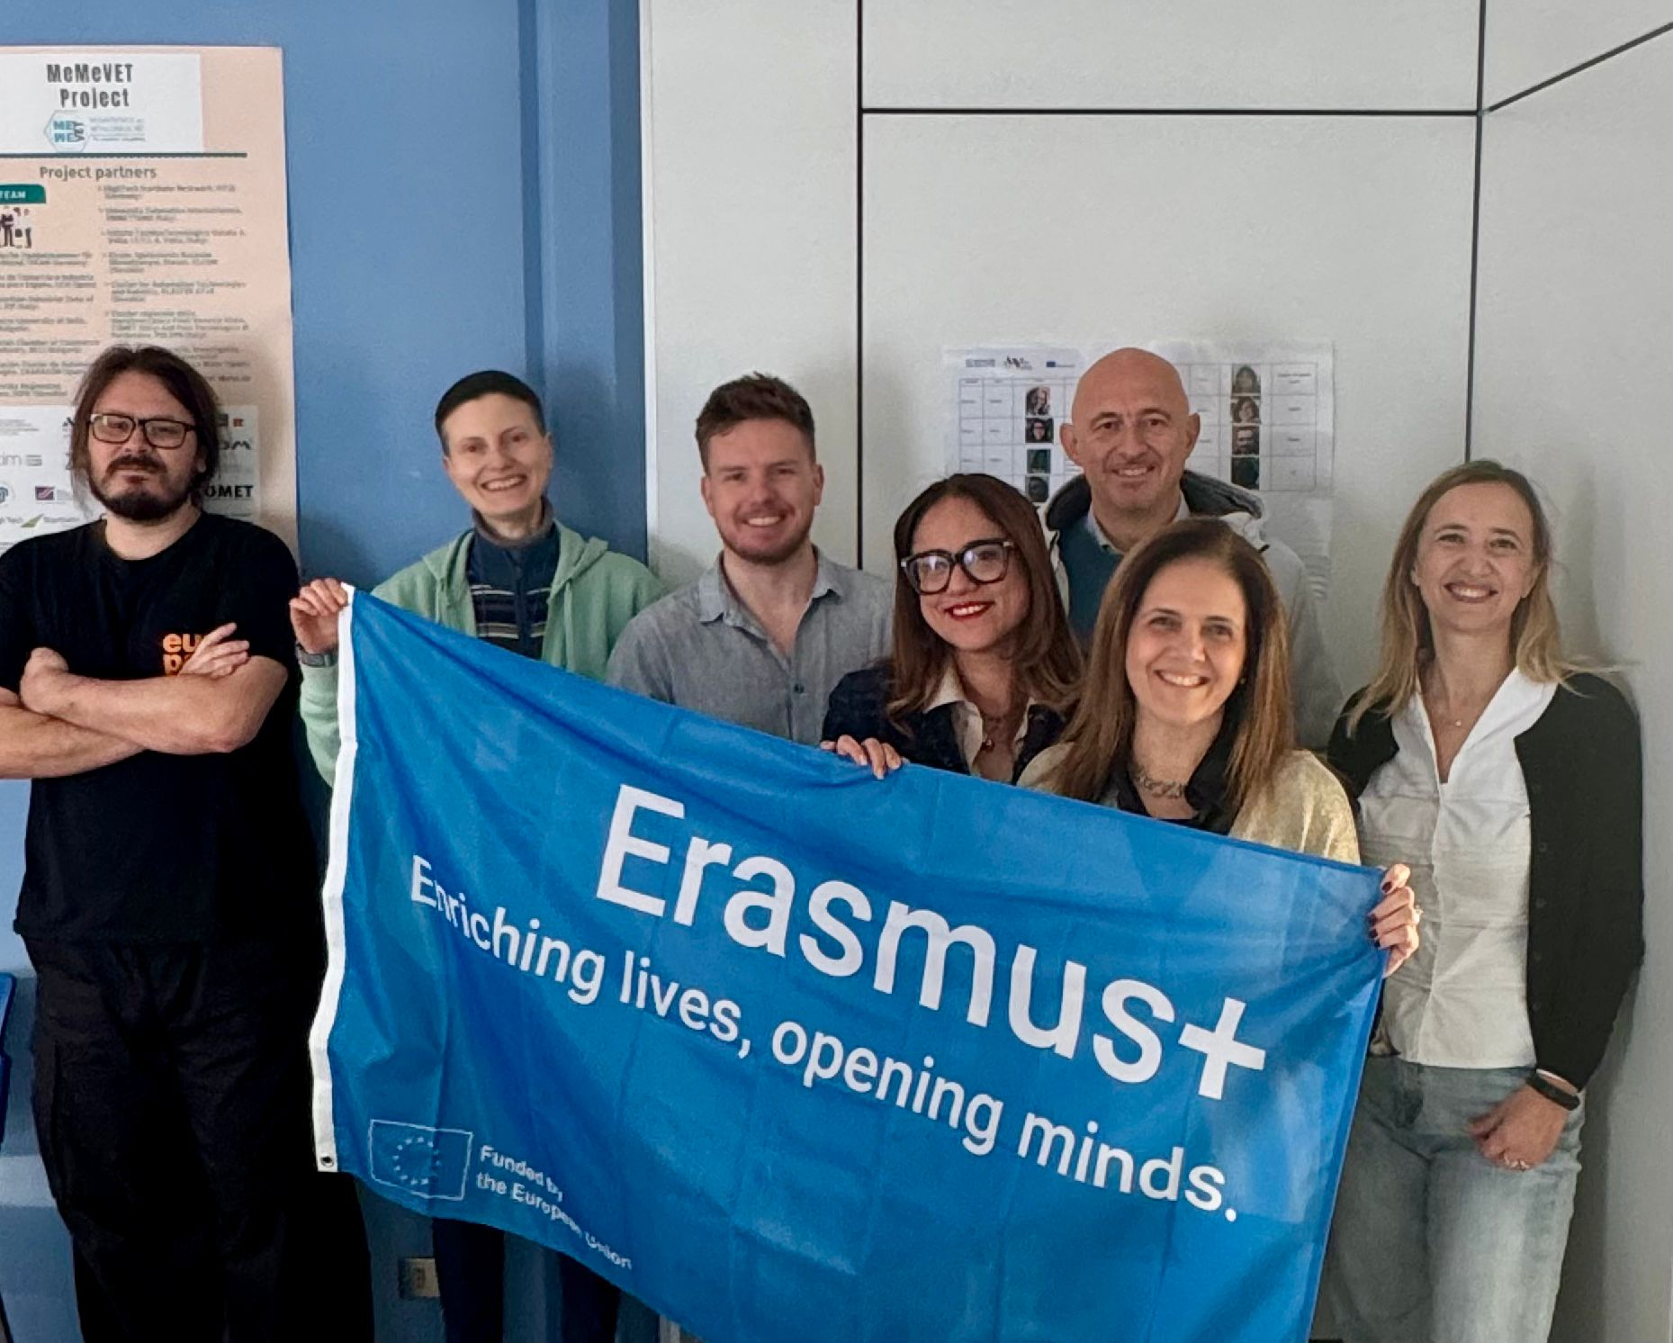
The project team in Perugia during the Phase 3 classroom visit, November 2025.

How Teacher Feedback Shaped the Platform
Teachers identified needs, tried prototypes and reported what needed to change. Their feedback informed the text adaptation, language support and lesson-planning features below.
Teachers identified a need for | The platform developed
Materials at different language levels | CEFR-based text adaptation in Text Adapter
Easy comparison of source and adapted texts | Side-by-side Original and Adapted views
More control over AI output | Editable content and section-by-section customisation
Support for difficult technical vocabulary | Difficult-word highlighting, explanations, and language objectives
More varied classroom activities | Activity Types and structured Learning Tasks
Better organisation of reusable material | Saved lessons, Resources, favourites, and class profiles

About the Classroom Examples
The examples draw on teacher reports, classroom observations and student feedback. They describe versions used during the project and show how teachers adapted the material to their classes. Use Part Four for the current application controls.

Part One: Introduction

Foreword
Teaching through an additional language requires clear language goals and support that helps students take part in the subject lesson. AI can help prepare adapted texts, vocabulary and tasks. Teachers select and check the material for their class.

How to Use This Handbook
This handbook is designed for dipping into, not reading cover to cover. New to CLIL? Begin with Part Two. Ready to use the platform? Go to Part Four. Planning tomorrow's lesson? Use the strategies and printable toolkit. Looking for classroom examples? Go directly to the case studies. Experiencing a technical problem? Use Practical Checks and Troubleshooting.

Part Two: CLIL Essentials

What CLIL Is
CLIL stands for Content and Language Integrated Learning. It means learning subject content through an additional language while deliberately supporting the language students need. A computer science teacher, for example, may teach network topologies in English while using diagrams, key vocabulary, sentence frames, and structured discussion. Students learn the technical content and develop the language needed to explain it. CLIL is not simply translating a normal lesson or adding a vocabulary list at the end.

The Four Cs of CLIL
The Four Cs help teachers connect Content, Communication, Cognition, and Culture. Use them as four planning questions rather than as abstract theory.
C | Teacher question | Example
Content | What subject knowledge or skill will students develop? | Identify and compare network topologies.
Communication | What language will students need? | One advantage of a star topology is...
Cognition | What thinking will students do? | Compare, justify, solve, evaluate, or design.
Culture | What perspectives, contexts, or assumptions matter? | How design choices vary across workplaces and users.

Language of, for, and through Learning
The language triptych helps teachers notice three different language needs in one lesson.
Layer | Meaning | Example
Language of learning | Subject vocabulary and structures needed to understand the content. | database, primary key, relationship; A primary key identifies...
Language for learning | Language students need to participate, ask questions, compare, and collaborate. | Can you explain...? Our group chose... I agree because...
Language through learning | New language that emerges as students think, interact, and refine understanding. | A student realises that efficient is needed to justify a design choice.
Try this: before your next lesson, note three examples of language of learning and three examples of language for learning. Leave space to record useful language that emerges during the lesson.

What Good CLIL Looks Like
In a strong CLIL lesson, the subject challenge remains meaningful while the language demands are made visible and manageable.
- The content objective is clear and intellectually worthwhile.
- Essential vocabulary and communication functions are identified.
- Students use language to explain, compare, solve, justify, or create.
- Scaffolds support participation but can be reduced over time.
- First languages may be used strategically to support thinking and access.
- Assessment reflects the intended content and language learning.

Common Challenges
Common CLIL difficulties are usually practical rather than theoretical. The response is often a small change in input, interaction, or support.
Common problem | Practical response
Too much unfamiliar vocabulary | Select 6 to 10 essential terms and recycle them.
Long or dense source material | Chunk the text and adapt only what blocks access.
Students understand but cannot explain | Provide sentence frames and rehearsal time.
Mixed language levels | Use the same content with different levels of support.
The subject teacher lacks language-teaching confidence | Focus on the language students need for the task, not on teaching the whole language system.
Students remain passive | Use structured pair or group roles with a clear product.

Supporting Multilingual Learners
A student's current proficiency in the language of instruction is not a reliable measure of subject knowledge or thinking ability. CLIL should create access to the content without assuming that all multilingual learners have the same background or needs.
- Find out what students already know and allow strategic use of their first languages.
- Use diagrams, demonstrations, models, and worked examples alongside text.
- Pre-teach essential language rather than every unfamiliar word.
- Check cultural references as well as vocabulary and grammar.
- Allow planning and rehearsal before public speaking.
- Offer more than one way to demonstrate understanding.
- Avoid simplifying the intellectual content unnecessarily.

Part Three: AI and Teacher Judgement

What AI Can Do for Teachers
AI is most useful as a planning assistant. It can produce a quick first draft, but the teacher remains responsible for accuracy, curriculum alignment, timing, inclusion, and classroom fit.
Function | Examples
Adapt | Change text complexity, shorten sentences, create parallel versions, explain general academic vocabulary.
Generate | Draft lesson ideas, discussion questions, collaborative tasks, rubrics, and exit checks.
Scaffold | Create glossaries, sentence frames, writing structures, reading stages, and discussion support.
Differentiate | Vary support, output demands, follow-up tasks, and extension without changing the core topic.
Treat every output as a draft. AI-generated material is not verified teaching material until a teacher has checked it.

CLIL Challenges and Possible AI Support
The following map connects common classroom problems with possible AI support and the professional check that still belongs to the teacher.
CLIL challenge | Possible AI support | Teacher check
Dense technical text | Create a more accessible or chunked version. | Has the technical meaning survived?
Mixed language levels | Produce parallel versions or different scaffolds. | Are expectations still fair and appropriately challenging?
Students cannot discuss the content | Generate sentence frames and question stems. | Do the frames match the real task?
Limited preparation time | Draft an activity sequence. | Is the timing realistic for this class?
Difficult vocabulary | Suggest definitions, examples, and visuals. | Are the definitions technically accurate?
Low participation | Suggest structured pair or group roles. | Will every student have a meaningful role?
Language-heavy assessment | Draft dual-focus criteria. | Is content being weighted appropriately?

Where AI Falls Short
AI can produce technically inaccurate explanations, invented references, broken links, unsuitable CEFR estimates, over-simplified content, generic activities, and unrealistic timings. It can also reproduce cultural assumptions or bias. AI cannot see the students, notice confusion, or sense when an activity is not working. These are human judgements.

Responsible and Ethical Use
Responsible use begins before information is entered into a tool and continues until the material has been taught and reviewed.

Before Entering Material
- Remove student names and identifying information.
- Do not enter health, family, disciplinary, or other sensitive information.
- Do not upload identifiable student work without an appropriate basis and safeguards.
- Check whether source texts, images, and videos may legally be uploaded or processed.
- Avoid uploading complete copyrighted textbooks or restricted materials.

Before Using Generated Content
- Verify subject accuracy and open every external link.
- Review the suggested language level and restore any important meaning that was lost.
- Check cultural references, stereotypes, and assumptions.
- Adjust timing, grouping, instructions, and assessment to the real class.
- Tell students when substantial material has been generated or adapted using AI.
- Do not use an AI-detection score as proof of cheating.
- Keep final teaching, assessment, and disciplinary decisions with a person.
Teacher review: accuracy, level, bias, privacy, copyright, links, and classroom fit.
SCHOOL-LEVEL CHECK
Follow your organisation's data protection, safeguarding, procurement, copyright, and AI-use policies. The EU AI Act's AI-literacy duty has applied since 2 February 2025. This handbook supports practical literacy, but it is not a legal compliance guide.
European Commission: AI literacy questions and answers

Using a General AI Tool
Use an AI assistant approved by your organisation. For practice, use the original text in the hotel-delivery worked example, or a short subject text you may share.
1. Start a new conversation. Remove personal information from the source and identify the class, subject goal and target language level.
2. Paste the source after this prompt: “I teach hospitality learners working at B1 English. Adapt the text below without changing its meaning. Add five useful terms with simple definitions, one short pair task and two content questions with answers. Source: [paste text].”
3. Compare the draft with the source. Check technical terms, quantities, instructions and suggested answers. Restore important details that have been lost.
4. Request one focused revision: “Keep the subject content. Shorten the sentences and add the frame ‘We ordered ___ but received ___.’” Check the revised output again.
5. Copy the useful material into your lesson, adjust it for the class and check the timing. After the task, use students’ answers to decide what needs changing. The Prompt Bank offers further starting points.

Part Four: Using the AI-CLIL Platform
CLIL Notebook is the project's AI-CLIL platform. Open https://clilnotebook.com and choose Continue with Google to sign in. Home gives access to your classes, Lesson Creator, Text Adapter, Resources and My Lessons. The examples below use a vocational ICT class learning about computer networks.

The Platform in Five Steps
1. Choose or create a class profile with the learners' age range, language skills and preferred activity types.
2. Decide what you need: a supported version of a text, a new lesson from a brief, or a CLIL version of an existing lesson.
3. Add trusted source material when it will help. Attach an existing lesson when you want to convert it.
4. Generate the material, then check and adjust its subject content, language support, activities and assessment.
5. Give the lesson a clear title, save it, and return to it through My Lessons.

Home and My Lessons
Home is the starting page. The four teaching-tool cards open Lesson Creator, Text Adapter, Resources and My Lessons.
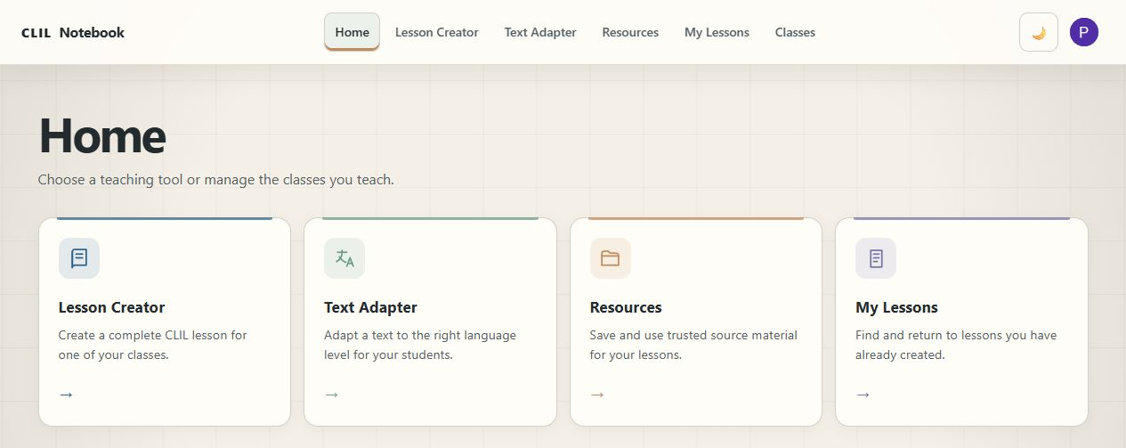
Fig. 1. Home provides access to the teaching tools.

Your Classes
Your Classes lists your saved class profiles. Select a class card to make it active, use its pencil icon to edit the profile, or choose Add class to create another. Describe the group without individual student details.
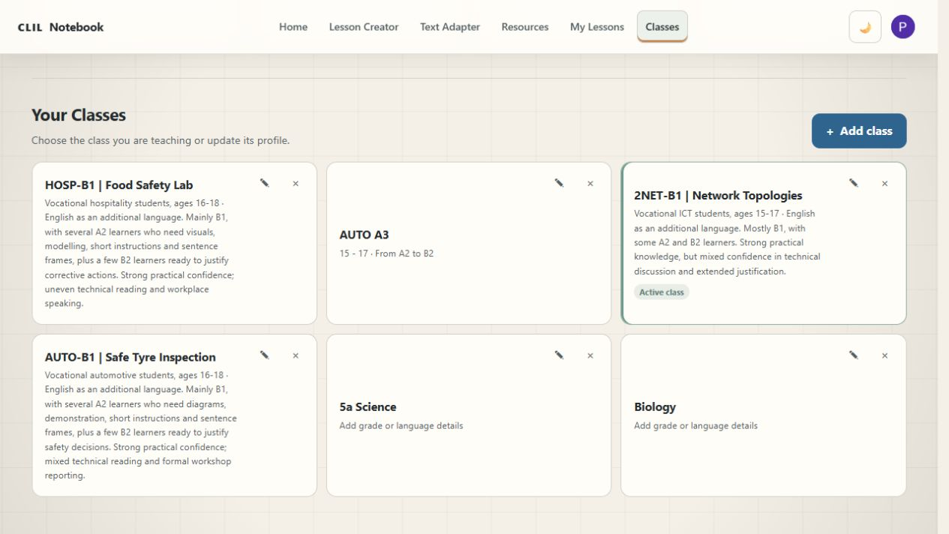
Fig. 2. Select a class profile or use the add and edit controls in Your Classes.
My Lessons contains saved lessons, grouped by date, with a separate Favourites area. Use the search field to find a title or topic, then open a lesson card to continue working. The star marks a favourite. Create a lesson opens a fresh lesson workspace.
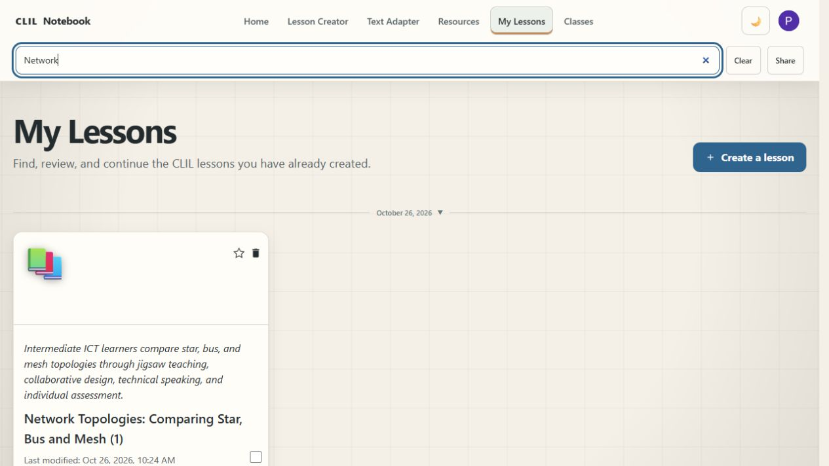
Fig. 3. Search saved lessons by title or topic in My Lessons.
The selection boxes and Share button provide a route for sharing selected lessons. Check what you have selected and who should receive it before completing a share. Keep student names and other personal information out of teaching examples.

Text Adapter
Text Adapter adjusts the language of an existing passage. Paste permitted source material into Source text, choose one or more CEFR levels from A1 to C2, and select Create supported versions. Need Translation? opens the translation tool. Text adaptation changes the language demand; it should preserve the subject ideas and essential technical terms.
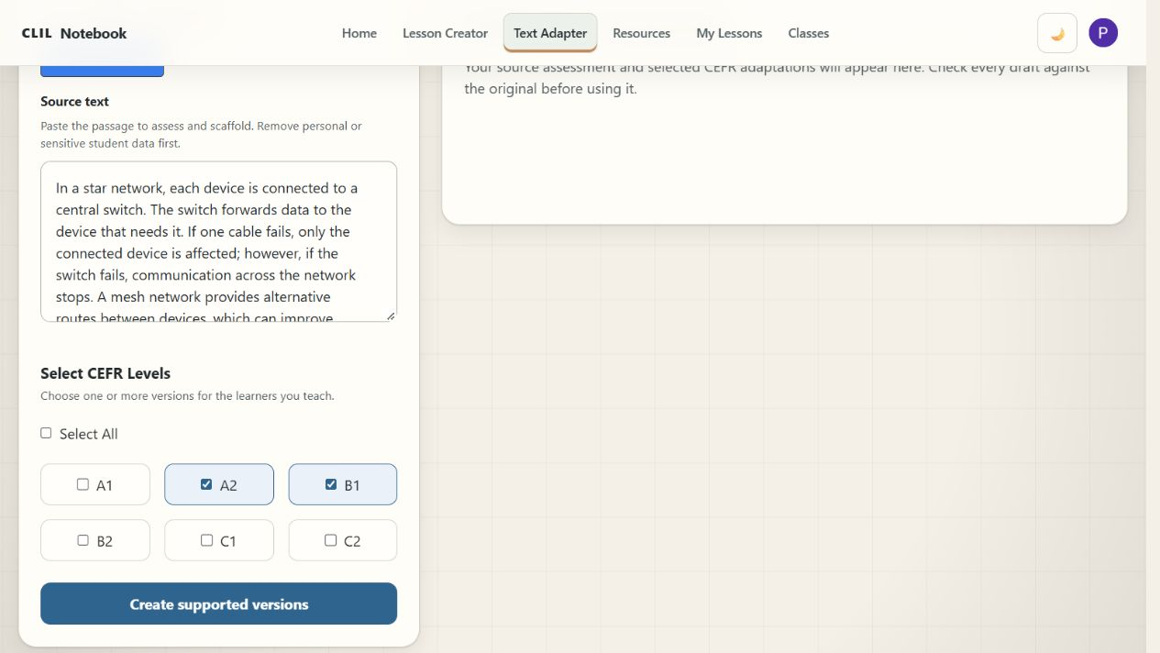
Fig. 4. Choose the target levels and use Create supported versions to generate adaptations.
The output includes an approximate assessment of the original text and a separate adaptation for each selected level. The explanations describe changes to vocabulary, grammar and organisation. Treat the CEFR labels as planning guidance, rather than a formal assessment of text difficulty or student proficiency.
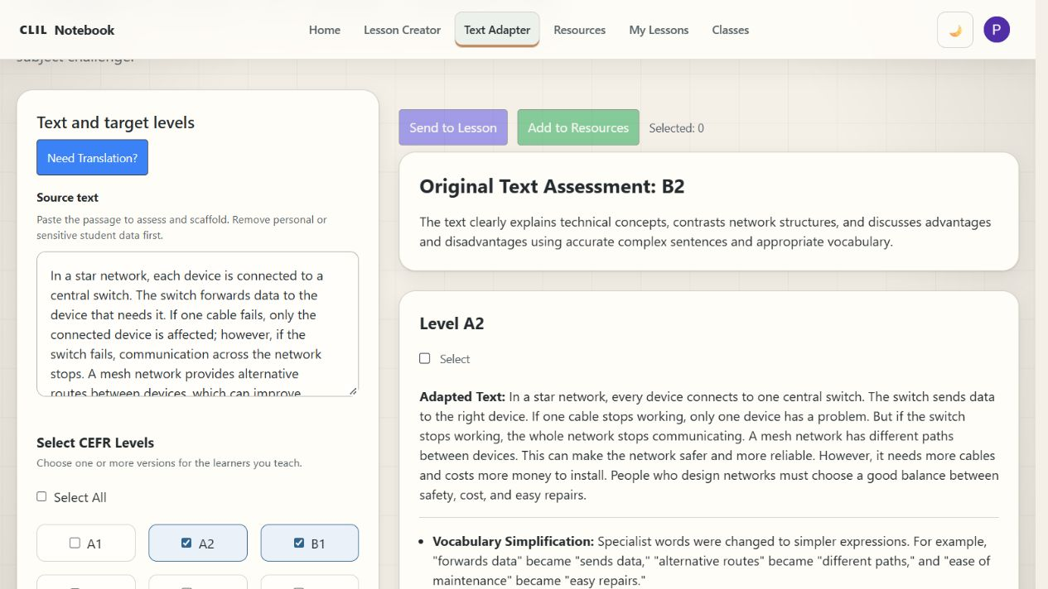
Fig. 5. The original assessment appears alongside the source and the adapted versions.
Compare each adaptation with the source. Check that cause and effect, qualifications, numbers and technical distinctions remain accurate. In the network example, reliability is a specific concept: a simpler expression should still explain whether the network continues working when a connection fails.
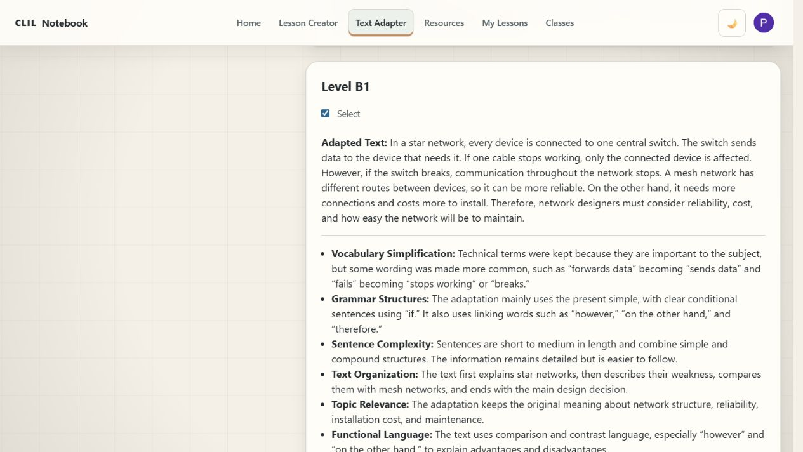
Fig. 6. A B1 version retains the comparison between star and mesh networks.
Select the checkbox beside a version you want to keep. Send to Lesson passes the selected material to the lesson workflow; Add to Resources stores it in your resource library. These buttons become available when a version is selected. Keep the source available for comparison.

The Lesson Creator
Lesson Creator builds a lesson from a teaching brief. Select the class in Choose a class, open Build your lesson, and enter the brief in What should the lesson cover? Source material is optional when starting from an idea. Use Attach source material when you want the lesson to draw on a particular document, link or saved resource.
Describe the topic, lesson length, learners, subject goal and language students will need. Add practical constraints such as available equipment, group size or a preference for paper-based work. A useful brief makes both the content goal and the communication task clear.
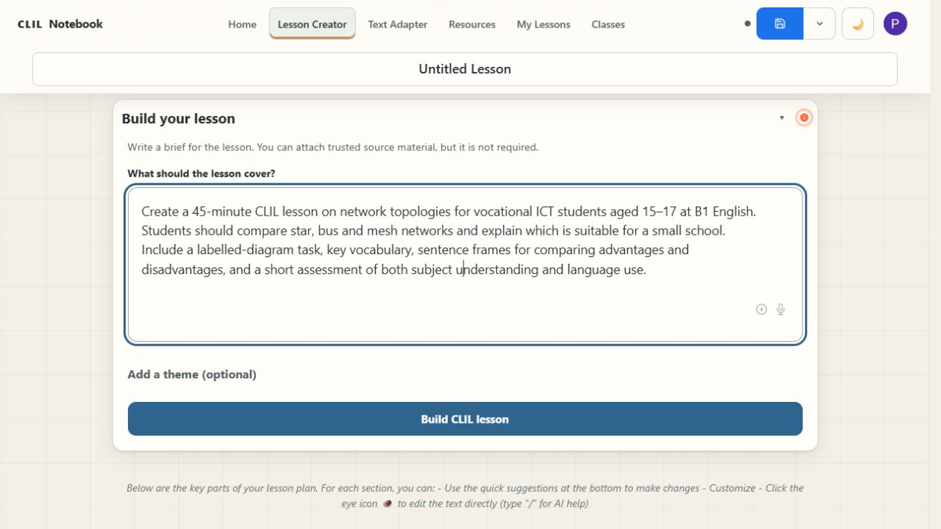
Fig. 7. A lesson brief specifies the topic, learners, time, language support and assessment.
For example: Create a 45-minute CLIL lesson on network topologies for vocational ICT students aged 15-17 at B1 English. Students should compare star, bus and mesh networks and explain which is suitable for a small school. Include a labelled-diagram task, key vocabulary, sentence frames and a short assessment of subject understanding and language use.
Add a theme is optional. When the brief and class are ready, select Build CLIL lesson. Wait for generation to finish, then open the numbered sections. The planning chat above the builder is a separate tool; writing in that chat does not by itself build the complete lesson.

Understanding Generated Lesson Content
The lesson is organised into five expandable sections. Open the section you need rather than reading every panel at once. Supporting notes provides an overview, core concepts, teaching approaches and suggested resources for the lesson.

1. Content Objectives
The Content Objectives section describes what students should know or do. Check that the objectives match the curriculum and are achievable in the available time. In the network example, students identify the structures, compare their advantages and disadvantages, and justify a suitable choice.
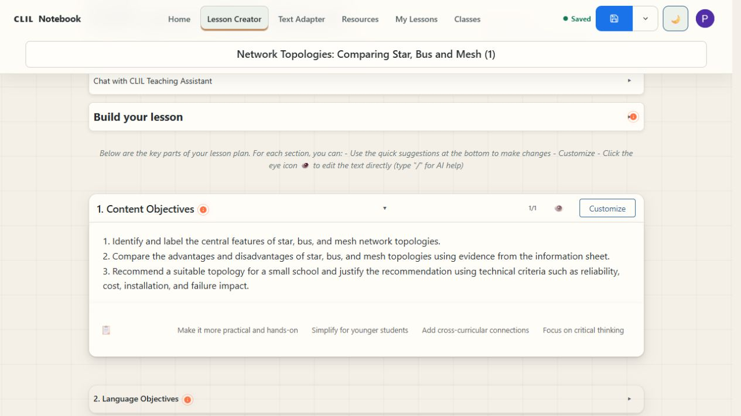
Fig. 8. Content objectives connect the technical topic with a decision students must explain.

2. Language Objectives
The Language Objectives section offers vocabulary, language structures and model phrases. Choose the terms students need for the task and practise the sentence frames before independent work. For comparing networks, useful patterns include A star topology has..., whereas... and We recommend... because....
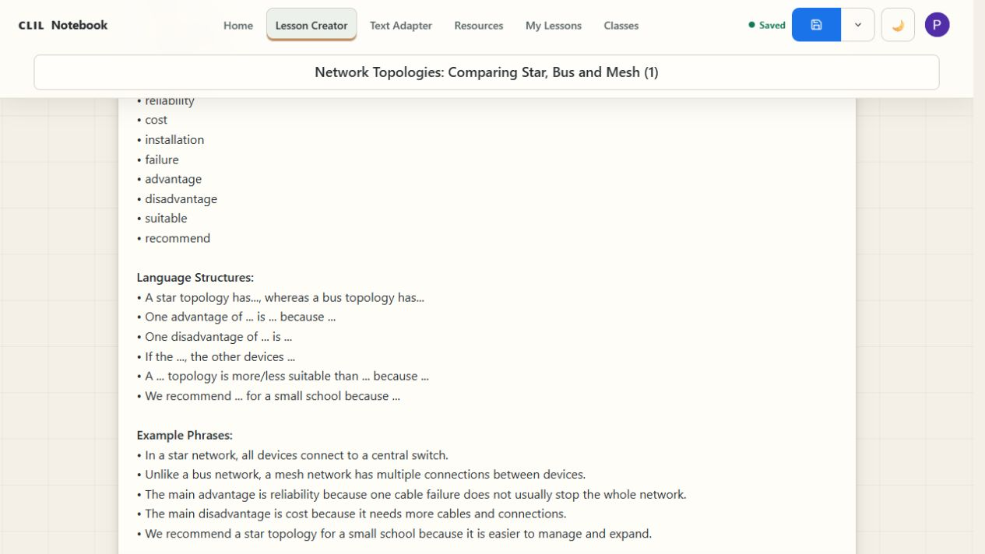
Fig. 9. Sentence frames help learners compare alternatives and justify a recommendation.

3. Learning Tasks
The Learning Tasks section contains classroom activities with suggested timing, materials and steps. Read the whole sequence before teaching. Check that handouts are actually provided, that equipment is available and that the total workload fits the lesson. Adjust grouping and language support for the class.
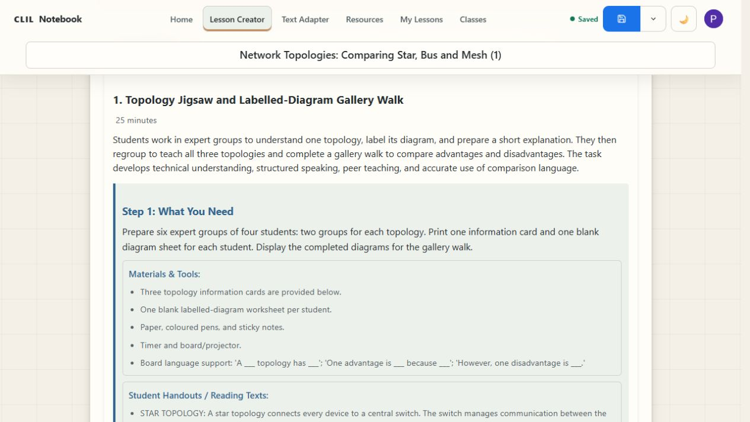
Fig. 10. A generated task combines diagram work, peer explanation and a gallery walk.

4. Assessment Criteria
The Assessment Criteria section suggests how to check subject understanding and language use. Decide what will count as successful work and explain this to students. Keep the criteria manageable: a labelled diagram, a justified recommendation and a short spoken comparison may provide more useful evidence than a long checklist.
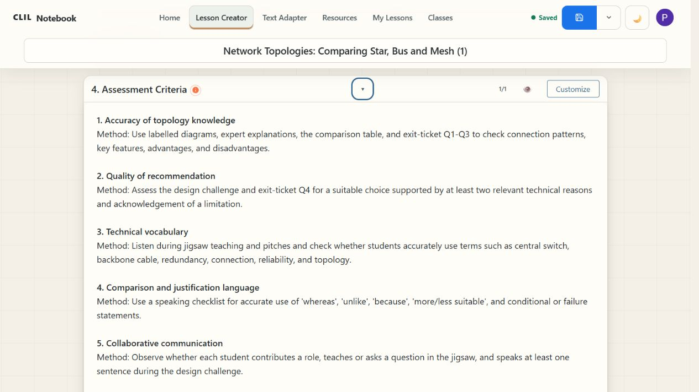
Fig. 11. Assessment suggestions include technical understanding and the vocabulary used to explain it.

5. Text Deep Learning
Text Deep Learning contains supplementary material such as key information, Socratic questions and extended writing tasks. Use the parts that serve your lesson. Check factual summaries against reliable sources, and choose extension tasks that fit the learners and available time.
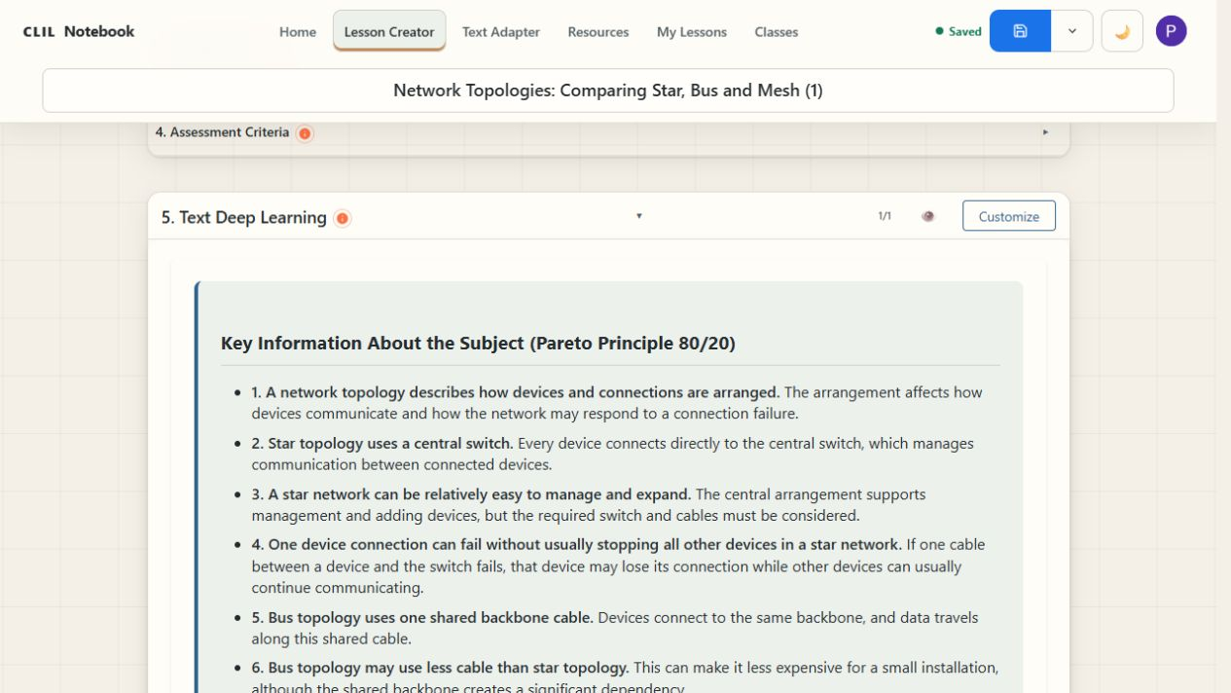
Fig. 12. Text Deep Learning provides a subject summary and follow-up material.

Customising Generated Content
Each expanded section has its own editing controls. Quick suggestions offer changes such as simplifying vocabulary or making a task more practical. Customize lets you give a specific instruction for that section, then apply the change. For example: Turn these criteria into a short checklist. Keep separate checks for network knowledge, comparison language and participation. Use clear B1 language.
Use the eye icon, labelled Edit text, to edit the wording directly. The editor includes formatting, copying and Export/Print controls. Apply your text changes before closing the editor, then save the lesson. Check the print preview before using a handout.
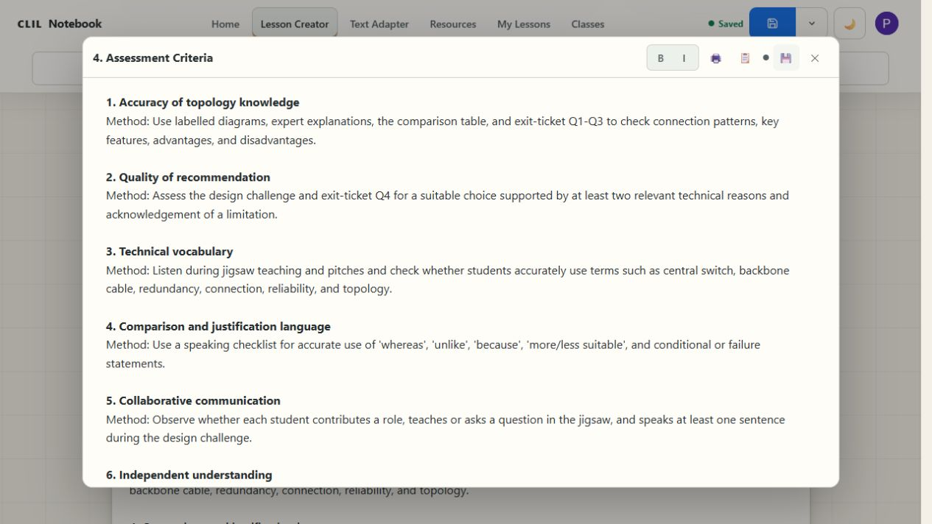
Fig. 13. Edit text opens the section for direct changes, copying and printing.
Use the save icon to update the current lesson. The adjacent arrow opens More save options; Save as new (copy) keeps a separate version. This is useful when adapting a lesson for another class or language level. Check the Saved status before leaving the page.
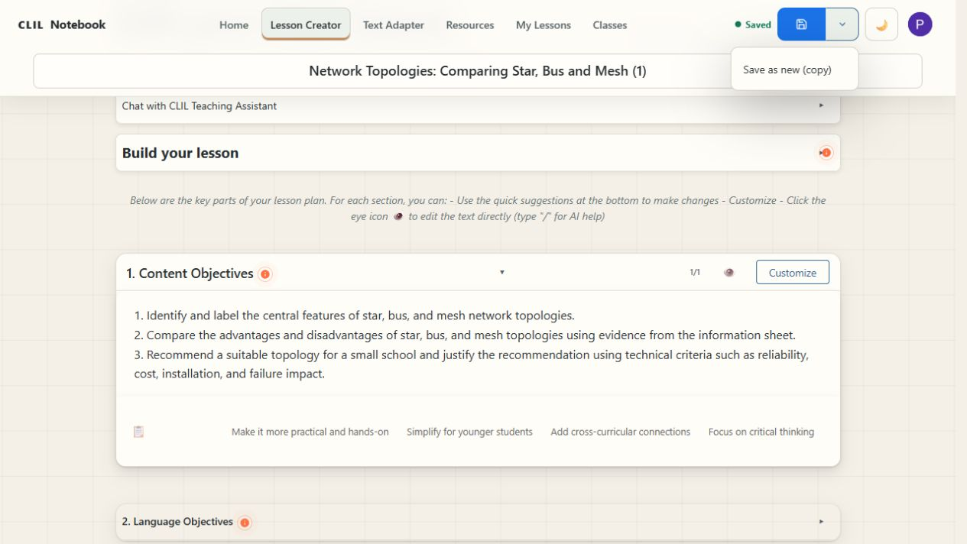
Fig. 14. Save as new (copy) preserves a separate version of a lesson.

Resources
Resources is your source library. In Add source material, paste a URL or write a note, then use Capture. Upload Files lets you add a document. Use material you are entitled to process and remove personal or sensitive student information before adding it.
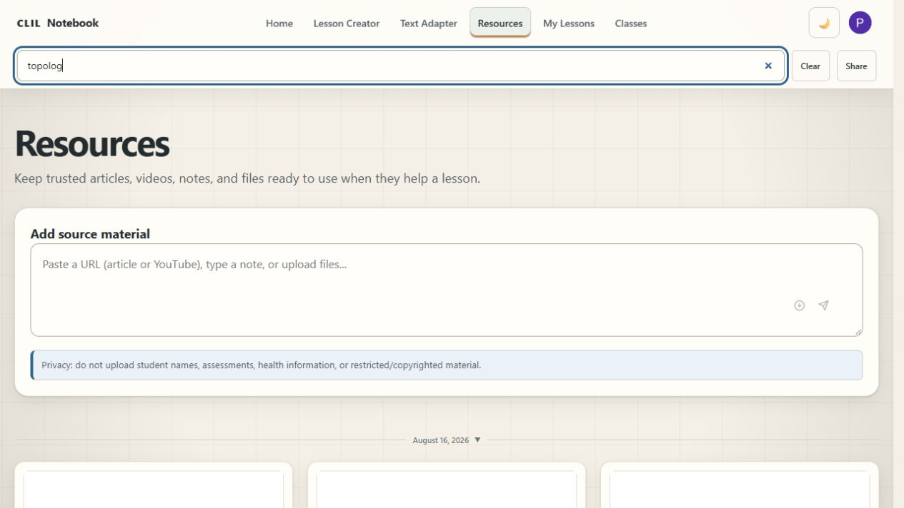
Fig. 15. Add source material accepts a URL, a note or an uploaded file.
Search the library to find a source. Open its title to inspect the summary and text. Where available, View Original Source opens the source, Copy Text copies its content, and Open in Text Adapter passes it to the adaptation tool. Check extracted text carefully, especially from scanned files or video transcripts.
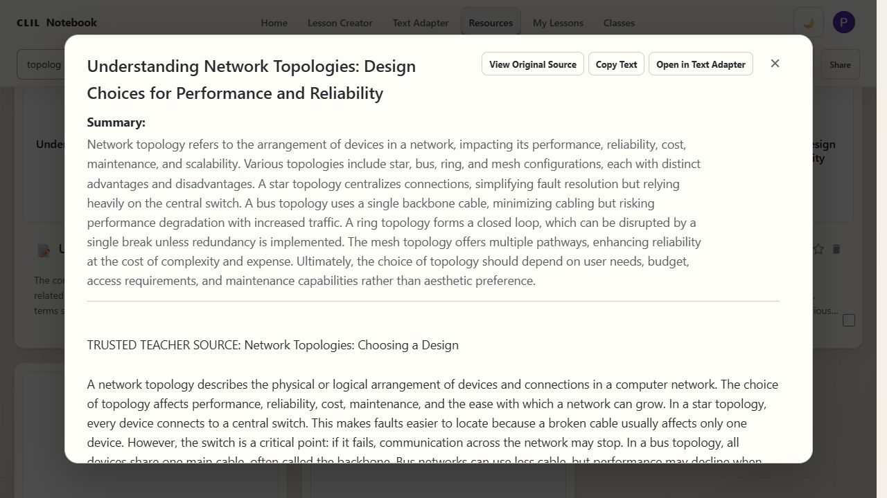
Fig. 16. An opened resource provides its text and actions for further use.
To attach a source to a lesson, open Build your lesson and select the plus icon labelled Attach source material. Choose From Resources, Add Link or Upload from Disk. In the resource picker, search for the source, open it and use Add this. Check that the intended attachment appears beside the brief before generating. The library's selection boxes also support sharing; simply storing a source does not tell the builder which lesson should use it.
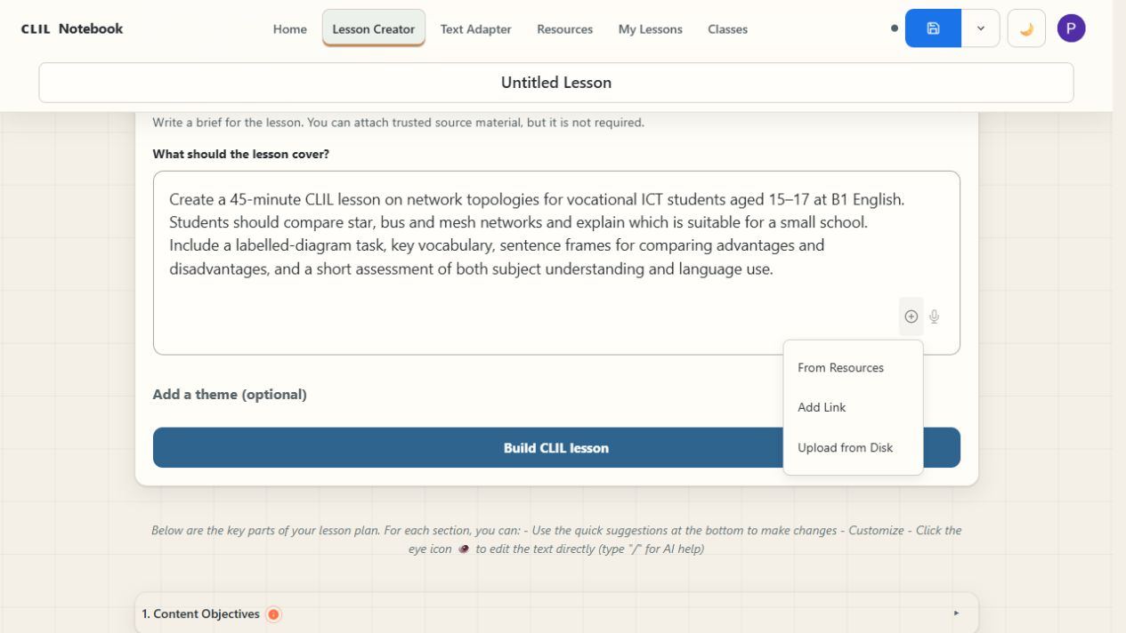
Fig. 17. Attach source material offers a saved resource, a link or a file from disk.

Converting an Existing Lesson
Conversion starts with a lesson you already have. Open a fresh lesson workspace, choose the class and attach the original lesson plan using Attach source material. Give a conversion instruction in Build your lesson, then select Build CLIL lesson.
For example: Convert the attached networking lesson into a CLIL lesson for this class. Retain its subject objectives, technical content and main activities. Add language objectives, essential vocabulary, sentence frames and support for reading and discussion. Include assessment of both the subject understanding and the language needed to explain it.
Compare the result with the original. Confirm that essential content and practical steps have been retained, and that the added language work helps students complete the subject task. Save the converted lesson under a clear title and keep the original. This differs from creating a lesson from a new brief: the existing plan is the starting point and a reference for checking the result.

Settings and Class Profiles
Use Add class or Edit class on Home to open the class settings. You can also reach Settings through the profile menu. Enter a class name, number of students, grade or age range, and a description of language skills. Describe the group rather than individual students; names, diagnoses and personal assessment records are not needed.
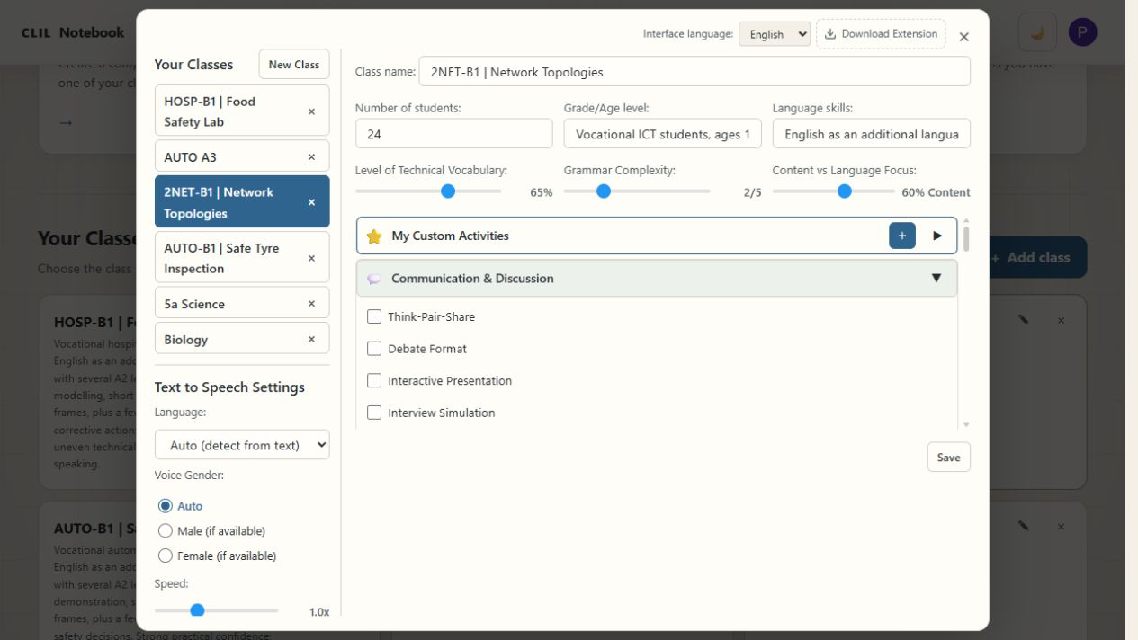
Fig. 18. Class settings combine group information, language controls and activity choices.
Level of Technical Vocabulary, Grammar Complexity and Content vs Language Focus guide generation. Set them with the task in mind. Learners who need simpler sentences may still need precise technical vocabulary and challenging subject content. The sliders express preferences; check the generated material against the actual class.
Select relevant activity types and use Save. Keep separate profiles for groups with different needs. Before generating a lesson, confirm the selected profile in Choose a class; changing a profile does not itself rewrite a saved lesson.

Voice Input and Reading Support
Microphone buttons beside the lesson brief, planning chat and customisation field offer dictation. If you choose to use them, your browser may ask for microphone permission. Check the transcribed wording before submitting it, especially subject-specific terms. You can always type instead.
Settings also contains Text to Speech Settings for language, voice preference, speed and pitch. Available voices depend on the browser and device. Test synthetic speech before using it with students: names and technical terms may need a teacher's pronunciation model. Dictation turns speech into text; text-to-speech reads text aloud.

Activity Types Library
The class settings group activities by purpose: communication and discussion; collaboration and group work; movement; inquiry; creative work; reflection; and independent study. Expand a category and select useful formats, such as Think-Pair-Share, Jigsaw Learning, Gallery Walk or Exit Ticket. These preferences guide the lesson brief; review the resulting tasks and timing.
My Custom Activities lets you add a familiar classroom format of your own. Use its plus button, give the activity a clear name and describe how it should work. Explain grouping, sequence, expected output and any language support. Save the activity and select it for the relevant class.

The Chat Teaching Assistant
Open Chat with CLIL Teaching Assistant for a planning conversation. You might ask for two ways to introduce a topic, help identifying language demands, or a shorter activity for the time available. Use this answer as the lesson brief transfers an answer into the builder, where you can edit it before selecting Build CLIL lesson.
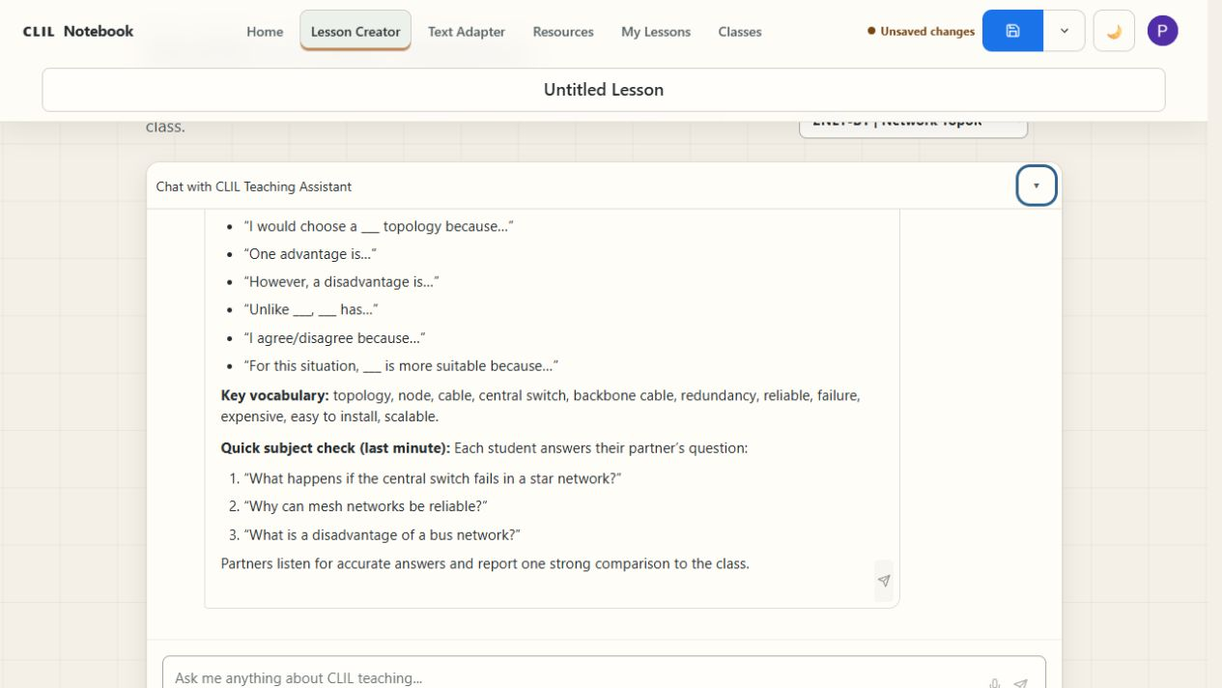
Fig. 19. The planning chat can suggest activities and language support before lesson generation.
Useful requests include: Ask me five questions before planning this lesson; Help me identify the language needed to explain this process; and Suggest two speaking activities for B1 learners. Keep requests focused and check suggestions against your subject knowledge.

The Chrome Extension
CLIL Notebook Capture is an optional Chrome extension for saving a webpage's URL and title to Resources. The Download Extension link in Settings opens its Chrome Web Store listing. In Chrome, review the listing and requested permissions, then follow the browser's installation steps if your organisation allows it.
Sign in to CLIL Notebook in the same browser before using the extension. Open the page you want to keep and use the extension to send it to your resource library. Check the captured source in Resources before attaching it to a lesson. On a managed school device, ask the administrator if installation is restricted; adding a URL directly in Resources remains available.

Interface Themes and Language
The theme button changes the light or dark appearance. Interface language is selected in Settings, with English, Italian, Spanish, French and German available. Choose the interface language that helps you navigate, and state the desired teaching language in your brief. The screenshots here use the English interface.

Tips for Getting the Most from the Platform
Start with one topic you know well. Use a precise brief, attach relevant sources, and keep the subject goal in view while adding language support. Generate, check, refine and teach. A focused adjustment to one section is often more useful than generating the whole lesson again.
Use clear lesson titles and save separate versions when adapting for another class. Keep source material, handouts and assessment instructions together. After teaching, note what learners found clear or difficult and use that feedback when revising the lesson.

Practical Checks and Troubleshooting
If a panel is difficult to use on a small screen, try a wider browser window or a desktop view. If a source cannot be read, check that it contains selectable text or provide a permitted text version. Check video transcripts and links before class.
Wait for generation to finish before starting another request. If it fails, keep a copy of the brief and source, check your connection and sign-in, and try again. Before closing a lesson, confirm that it is saved. Prepare the handouts or copies you need before teaching so that a live connection is not essential for every classroom activity.

Part Five: Practical CLIL Strategies

Adapting Texts
A source text may contain unfamiliar words, long sentences or compressed explanations that make the subject difficult to follow. Adapt the parts that obstruct understanding while keeping the technical meaning.

Keep, Change, and Check
Keep | Change when needed | Check
Essential technical terms and core meaning | Sentence length, density, uncommon general vocabulary | Has any important qualification disappeared?
Important cause-and-effect relationships | Unnecessary cultural references and obstructive passive structures | Is the intellectual challenge still meaningful?
Useful diagrams and examples | Organisation and chunking | Is the adapted text actually easier for this class?
Check sentence length, vocabulary and paragraph structure against the needs of the class. Keep essential concepts, cause-and-effect relationships and qualifications.
From the pilot
In class 3 AINF, a teacher used adapted texts about bias in artificial intelligence. The B1 version reduced the word count from 603 to 416 while retaining the main ideas. Students read both versions and discussed which was clearer, which words were difficult, and what changed. Several students were unfamiliar with the reference to The Great Gatsby. In the available responses, nine of fourteen students made a broadly appropriate connection between the cultural reference and bias in AI training data, while five could not explain it. This showed that cultural references can create barriers even when vocabulary and sentence structure are accessible.
Parallel versions can support comparison or different language needs. For example, use an accessible version for a first reading and a more demanding version for further discussion.

Supporting Vocabulary
Technical subjects often combine specialist terms, abstract nouns and words with different meanings in everyday and subject English. Select the language students need for the task.

A Six-Step Vocabulary Routine
1. Select 6 to 10 essential words.
2. Separate technical terms from general academic words.
3. Write student-friendly definitions.
4. Add one visual, example, or non-example.
5. Provide a sentence frame that uses the word.
6. Recycle the words during discussion, writing, and review.
The project reports show that even when a text was successfully adapted, some terms still caused difficulty. Students in the jQuery lesson highlighted words like 'querying,' 'DOM,' 'lightweight,' and 'straightforward.' In the relational databases lesson, advanced learners noted difficulty with dense academic vocabulary like 'feasible,' 'encompassing,' and 'usability.' Adaptation does not remove the need for focused vocabulary work.
AI can suggest definitions, examples, matching tasks and sentence frames. Check the terminology, then select the support your learners need.
Try it
Ask for a definition, an example and a reusable sentence frame for each term. For parsing: Definition: Interpreting the structure of data so a program can use it. In context: A parser reads a JSON file and makes its data usable by the program. Sentence frame: We use parsing when we need to...

Building Reading, Speaking, Writing, and Listening Scaffolds
Use a glossary for unfamiliar terms, a model for a new text type or sentence frames for discussion. Match the support to the task.
Skill | Possible scaffolds
Reading | Headings, chunked text, glossary, guiding questions, diagram.
Speaking | Sentence starters, roles, useful phrases, rehearsal time.
Writing | Model answer, paragraph frame, linking words, checklist.
Listening | Key words in advance, short sections, repetition, visuals, note-taking grid.
Reduce support as learners become more independent.
In the project, discussion questions, review checklists and step-by-step prompts helped students discuss technical topics in English and understand the assessment criteria.

Creating CLIL Tasks
Give students a task that uses the content: compare alternatives, solve a problem, explain a process or produce something.

Task Quality Check
- Is there a clear subject outcome?
- Do students need to communicate to complete the task?
- Is the language support visible and usable?
- Does the task require meaningful thinking?
- Does every student have a role?
- Is there a clear product or decision?
- Is the timing realistic?
A useful way to think about task design is across three stages: before the main task (key vocabulary, activating questions, prediction prompts), during the main task (guided reading, coding challenge, group design task, discussion structure), and after the main task (reflection questions, summary, presentation, transfer activity).
Project examples included network quests, Java programming tasks and group design work. The case studies show how teachers added language support to these activities.
From the pilot
In the computer networks lesson with class 1 EQ (fourteen-year-olds at B1 level), the teacher created an 'Internet and Network Quest', a gamified small-group exploration with collaborative research, quizzes, and group presentations. Students also completed a paired email-writing exercise using five practical scenarios, followed by peer feedback using a netiquette checklist.

Differentiating for Mixed Language Levels
Some learners can work with dense reading and open-ended discussion; others need shorter texts, explicit vocabulary or a planning frame. Vary the support around a shared subject goal.
- Keep the same core content and vary the language support.
- Use the same task with different sentence frames or planning grids.
- Offer parallel text versions while keeping a shared class discussion.
- Vary the support before varying the expected outcome.
- Provide optional extension rather than unnecessary extra work.
- Use flexible pairing and regrouping.
The project provides several useful models. In some Phase 1 lessons, teachers compared B1 and B2 versions of the same text to observe which improved comprehension while preserving meaning. In the abstract classes work, a simplified follow-up activity was created for students who found the original task or the English too demanding. In class 5 AINF, the teacher deliberately used B2 and C1 versions because the students were ready for them.

Supporting Migrant and Multilingual Learners
The project aimed to support more inclusive teaching for learners who face language barriers, including migrant and multilingual students.
Do | Avoid
Find out what students already know. | Assuming language difficulty means low ability.
Use home languages strategically. | Removing all challenging content.
Use visuals, demonstrations, and models. | Asking one multilingual student to translate constantly for others.
Explain local and cultural references. | Treating multilingual learners as one homogeneous group.
Allow planning before speaking. | Correcting every language error during subject discussion.
Adapted input, core vocabulary and sentence frames can help learners show subject knowledge while developing the language needed to explain it.
Where useful, allow learners to plan in a shared language before producing English, and connect new concepts to examples they know.

Turning Existing Lessons into CLIL Lessons
Start with an existing lesson and make its language demands explicit.

A Six-Step Conversion Process
1. Identify the central content objective.
2. Identify the language students need to understand and participate.
3. Review the source material for density, vocabulary, and cultural barriers.
4. Add input support such as visuals, chunking, or an adapted version.
5. Add structured communication using pairs, groups, sentence frames, or roles.
6. Add a short assessment that makes the content learning visible.
Keep the subject content that already works. Add the vocabulary, scaffolds and opportunities to communicate that students need.
Check each change against the content objective and the needs of the class.

Example: Converting a Standard Lesson
This illustrative planning sequence draws on the computer networks work with class 1 EQ at Alessandro Volta.
Starting point. A dense subject text about TCP/IP protocols, DNS and internet services.
CLIL adaptation. Step 1: Content goal. Students should understand the role of key internet protocols and explain what DNS does. Step 2: Language. Pre-teach key terms (protocol, browsing, cloud storage, server, client) with definitions and example phrases. Step 3: Use the Text Adapter to prepare a B1 version, then check it against the source. Keep both for comparison. Step 4: Organise an 'Internet and Network Quest' in small groups: each group researches one protocol, then quizzes the others. Step 5: Provide sentence frames: 'The purpose of [protocol] is to...' and 'This protocol is important because...'. Step 6: Ask 'What does DNS stand for and why is it important?' and have students explain the role of one other protocol in English. Check the technical explanation and use of key terms separately.

Part Six: Classroom Case Studies
These cases draw on project reports and student feedback. Choose one by the teaching problem: text difficulty, vocabulary, group work, assessment or introducing the tool to colleagues. They describe trial versions of the platform; use Part Four for the current controls.
Italian class codes identify the year group and study pathway. For example, 4 AINF is a fourth-year ICT class. Teacher and student comments are drawn from project reports and questionnaires. Where comments were translated from Italian, the wording has been kept as close as possible to the original meaning.

Case Study 1: Computer Networks and Netiquette
CLASS | 1 EQ, Electronics; 10 students aged about 14; B1 English
SUBJECT | Computer networks, internet services, and netiquette
TEACHER | Laura Rosati, Alessandro Volta Institute
DURATION | Two sessions: 104 minutes and 50 minutes
The class consisted of ten students aged about fourteen, working at approximately B1 English. The teacher began by uploading resource documents about internet services and computer networks to the platform, which assessed the original text as C1 level. She then used Language Tools to adapt the content down to B1 by simplifying vocabulary, shortening sentences to an average of 10–15 words, and restructuring with clear headings and bullet points, while keeping the core technical content intact.
The platform generated two activities: an 'Internet and Network Quest' (a 90-minute gamified group exploration) and a Netiquette Email Writing Task. It also produced a key vocabulary list (internet, services, browsing, communication, resources, cloud storage) with language structures and example phrases. The teacher found the vocabulary list and the Read Aloud pronunciation feature especially useful for these younger learners.
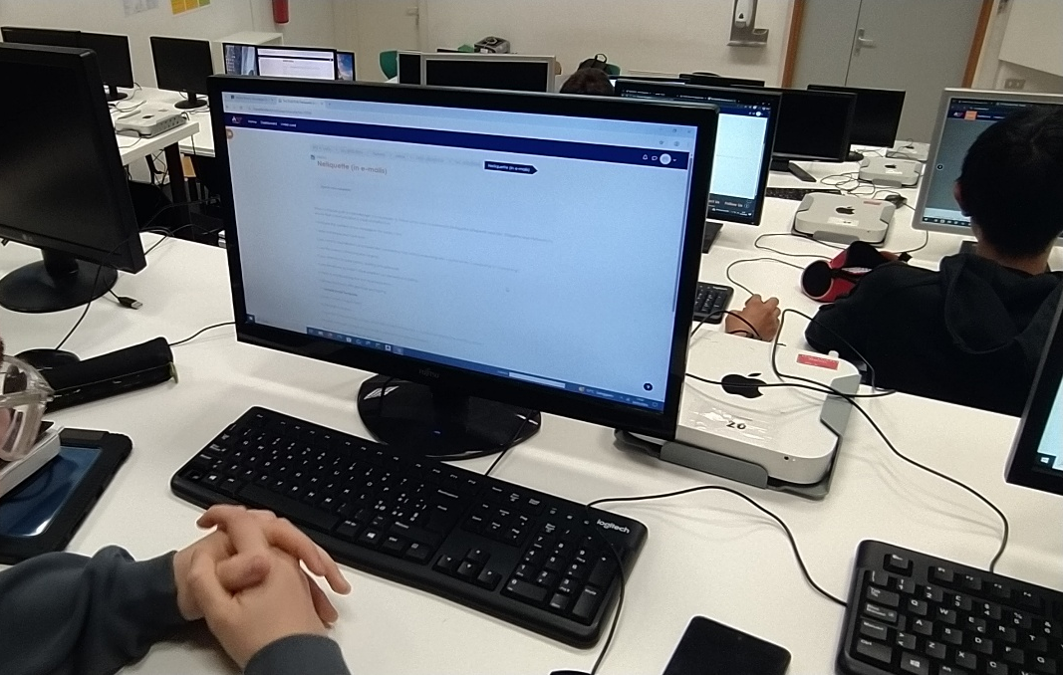
Class 1 EQ working on the platform during the computer networks lesson.
For the email task, students worked in pairs. Each pair drafted two emails: one demonstrating proper netiquette and one deliberately including common mistakes, using scenarios like requesting time off, following up on a job application, and coordinating a group project. They then exchanged emails for peer feedback using an eight-rule netiquette checklist. The teacher also used the platform to generate an interactive HTML/JavaScript multiple-choice test with animations, hover effects, and a real-time score counter, all in Italian, which she shared on the school's official learning platform.
"It was very useful to have a list of Key Vocabulary to introduce in class at the beginning of the lesson."
Laura Rosati, teacher
"I used this tool to translate the Italian texts to an English level suitable for the students. The original assessment established that the text was C1 level. It was translated to a B1 level."
Laura Rosati, on using Language Tools
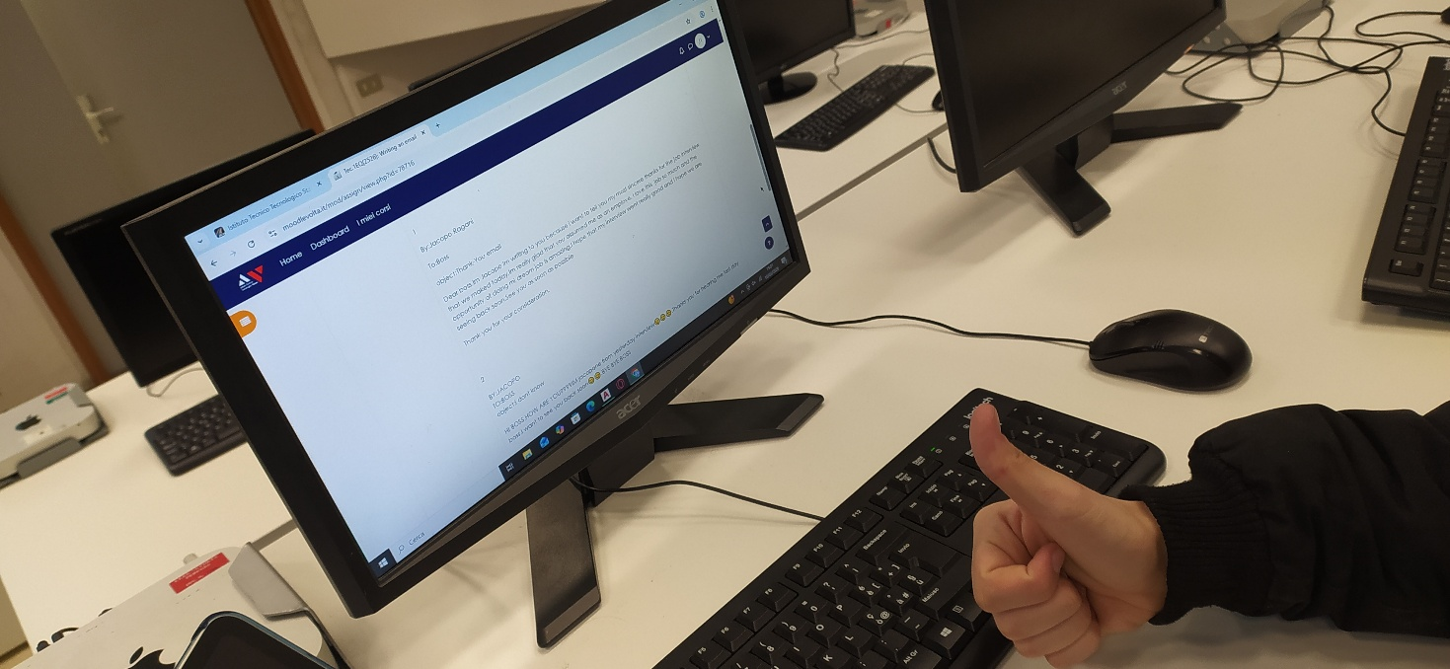
A student in class 1 EQ working with the platform in the school lab.
Ideas for your classroom
Combine an adapted text, a small vocabulary set and one communication task. Check text-to-speech pronunciation before class.

Case Study 2: jQuery and Parallel Text Comparison
CLASS | 4 AINF; 19 students aged about 18; B2 English
SUBJECT | jQuery and web programming
TEACHER | Laura Rosati, Alessandro Volta Institute
FOCUS | Parallel B2 and B1 text comparison
This was the first time this teacher had used an English text with this class, and students were anxious. The teacher deliberately chose a short text: an explanation of what jQuery is, why libraries matter, and how cross-browser issues affect web development, as a manageable entry point.
Students were given two versions: one at B2 level and one adapted to B1. The B1 version shortened sentences, simplified vocabulary, and replaced rare words while keeping the core explanation. Students read both, identified unknown words and difficult phrases, and compared the two.
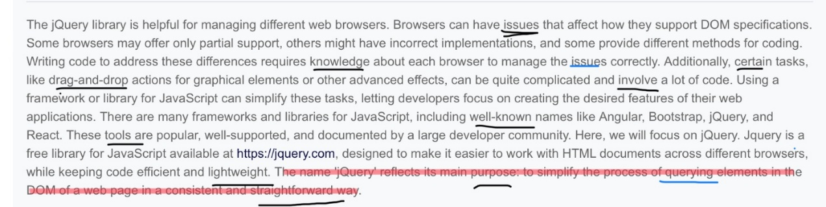
A student's annotated jQuery (B2) text, with words like 'issues' and 'querying' marked as difficult.
Many students found the B1 version easier to understand, while some noted less detail, remaining difficult language, or syntactic inaccuracies. Their specific feedback identified exactly where barriers lay: words like 'querying,' 'DOM,' 'lightweight,' and 'straightforward' in the B2 text, and 'dragging,' 'advanced,' and 'features' in the B1 text. One student observed that the B1 version used a 'simplified lexicon allowing comprehension of more words, for example, mistakes instead of issues.' Another noted it was 'more compact and understandable with additional explanations.'
"Students were quite scared about studying computer science in English, but then they showed to have quite understood the text."
Teacher observation
Ideas for your classroom
Ask students to compare two versions and identify the exact words or structures that cause difficulty. Use their answers to plan vocabulary support.

Case Study 3: AI Bias, Language, and Cultural References
CLASS | 3 AINF; 14 students aged about 17; B1-B2 English
SUBJECT | Bias in artificial intelligence
SOURCE | Official computing textbook
FOCUS | Meaning, language level, and cultural accessibility
This lesson was different from the procedural computing topics elsewhere. It asked students to understand both a technical concept (how machine learning systems absorb bias through training data) and its social implications. The teacher introduced the topic through a B1 version first, then a B2 version, so students could compare the two.
The B2 text was significantly longer (603 words versus 416 in the B1 version). After reading, students completed a structured eleven-question survey asking whether meaning was maintained between versions, which sentences were most difficult, and whether their challenges came from the content or the language itself.
Several students were unfamiliar with the reference to The Great Gatsby. In the available responses, nine of fourteen students made a broadly appropriate connection between the cultural source material and the risk of bias in AI training data, while five could not explain the reference. The episode showed that cultural accessibility can matter as much as vocabulary or sentence complexity.
The teacher noted that this activity was more effective than teacher-led instruction alone because students read the text carefully and repeatedly, engaging with both the content and the language.
"This is what surprised me most about the tool: by dividing the text into paragraphs and comparing them between B1 and B2, there is no loss of important information."
Teacher observation
Ideas for your classroom
A text can be linguistically accessible and still exclude learners through unfamiliar cultural references. Check both language and assumed background knowledge.

Case Study 4: Advanced Learners. Relational Databases at C1 Level
CLASS | 5 AINF; 12 students; B2-C1 English
SUBJECT | Relational DBMS rules and Codd's thirteen rules
SOURCE | Official computing textbook
FOCUS | B2-C1 comparison for advanced and examination-level learners
The teacher used B2 and C1 versions of a demanding text on relational database rules with this advanced class preparing for its state examination. The rules were numbered from 0 to 12 for comparison. A B1 version was prepared but not used.
Students compared the versions, identified unfamiliar terms and answered content questions about missing information and operations on base tables.
The teacher reported independent, concentrated work and explained that the activity would help students prepare for the interdisciplinary interview in their examination.
The teacher reported that almost all students received additional credit for their work and would have continued writing if more lesson time had been available.
Ideas for your classroom
Ask students to choose the clearest wording for each rule and explain their choice. Adaptation can support close reading at advanced levels as well as access to a difficult text.

Case Study 5: Building Access Pathways. Abstract Classes in Java
CLASS | 4 AINF; 19 students aged about 18; B2 English
SUBJECT | Abstract classes in Java and pair programming
TEACHER | Laura Rosati, Alessandro Volta Institute
DURATION | Two sessions: two hours and one hour, March 2026
Students were assigned a project-based task in object-oriented programming, designing and implementing abstract class structures for real-world applications. Working in groups, they chose from five application scenarios: a gaming application, a banking system, an e-commerce platform, a transportation system, or a scheduling application. Then they created class hierarchies, wrote Java code, and presented their solutions.
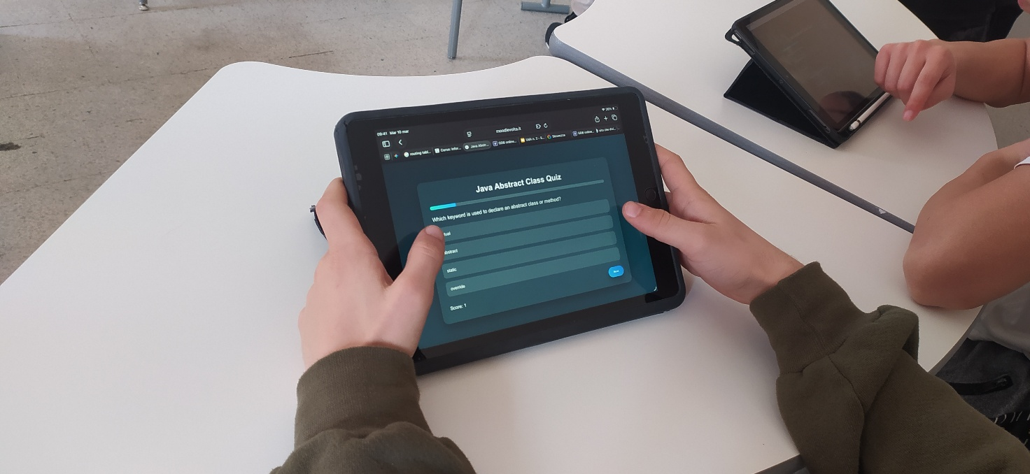
Class 4 AINF doing the platform-generated quiz on iPad during the abstract classes activity.
In a second session, the teacher generated a simpler explanation for students who needed help with the English or the concept. It used Animal and Vehicle as familiar examples. Students extended provided abstract classes with concrete implementations before returning to the main coding task.
The teacher reported that the follow-up was useful to the whole class, including students who had completed the original task.
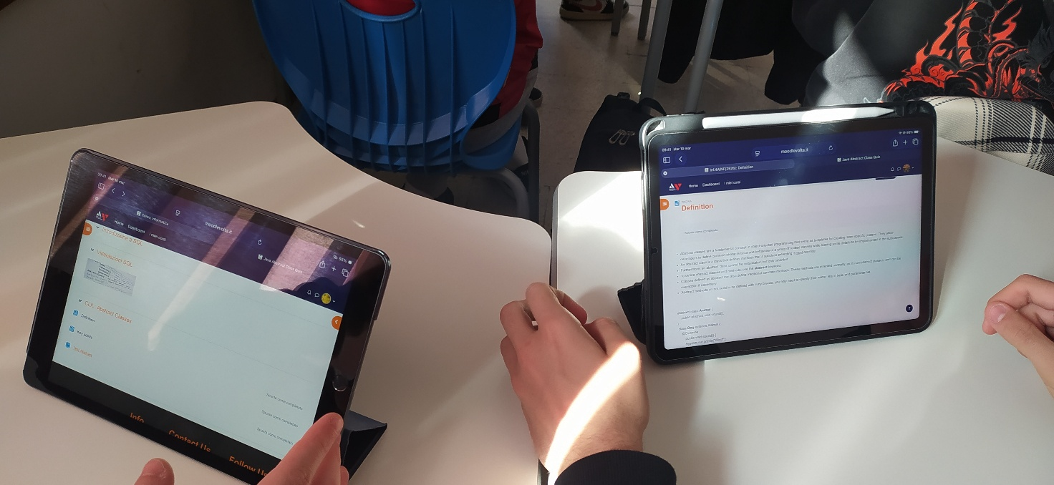
Two students working on iPad during the abstract classes project.

Pair programming on iPad during the abstract classes project.
Ideas for your classroom
A simpler follow-up can provide a route back into the original challenge. Keep the concept, reduce the language load, and reconnect learners to the main task.

Case Study 6: From Generator to Classroom. UML and Aggregation
CLASS | 4 AINF; 19 students; B2 English
SUBJECT | UML design and Java aggregation relationships
FORMAT | Vocabulary, modelling, group programming, and review
DURATION | Three sessions, November 2025
On 4 November, the teacher introduced vocabulary from the Language Objectives section and led a shared warehouse-design example using UML (Unified Modeling Language). UML diagrams show classes in a program and the relationships between them. Students then practised independently.
On 12 November, groups worked on five Java projects using iPads. Each project involved a UML diagram, code and documentation. The tasks used aggregation: one object holds a collection of other objects. Generated checklists and discussion questions helped students understand the work and assessment.
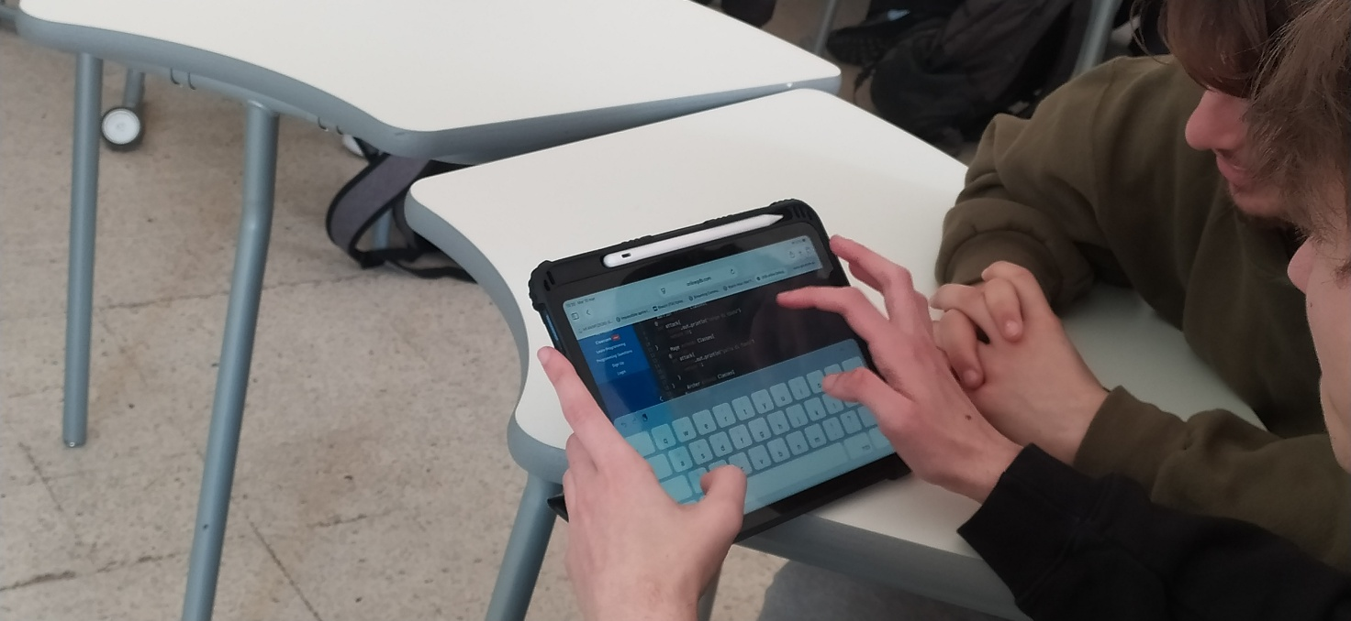
Group work on the UML and aggregation task, November 2025.
The teacher found the discussion questions useful for talking about technical concepts in English. They included 'How did the UML diagram clarify the relationships between objects?' and 'Why is aggregation important in managing data?'
On 13 November, students completed their projects and were graded using the rubric. The teacher gave collaboration and participation 4 out of 10 points, double the weight of any other criterion. This was a choice for this activity, encouraging students to discuss the work in English.
Ideas for your classroom
Explain the criteria before group work and adjust their weightings to the lesson objectives. Use a shared example before students work independently.

Case Study 7: Phase 3 Classroom Shadowing. Three Approaches to One Platform
CONTEXT | Phase 3 visit to Perugia, 10-13 November 2025
CLASSES | Three ICT classes with different teaching approaches
OBSERVERS | Teacher Academy Ireland project team
FOCUS | Student-led projects, interactive text, and direct instruction
During the Perugia visit, the Teacher Academy Ireland team observed three classes using the platform for group programming, a reading-and-speaking activity and direct instruction.

Class 1: Student-Led Java Projects (Laura)
Students worked in groups from platform-generated briefs with coding objectives and UML guidance.
In the Music Quiz group, one student coded while another prepared the UML structure. In the Hotel Management group, students divided the code and diagram work. Other groups built a calorie tracker, a sports-league application or a Java game.
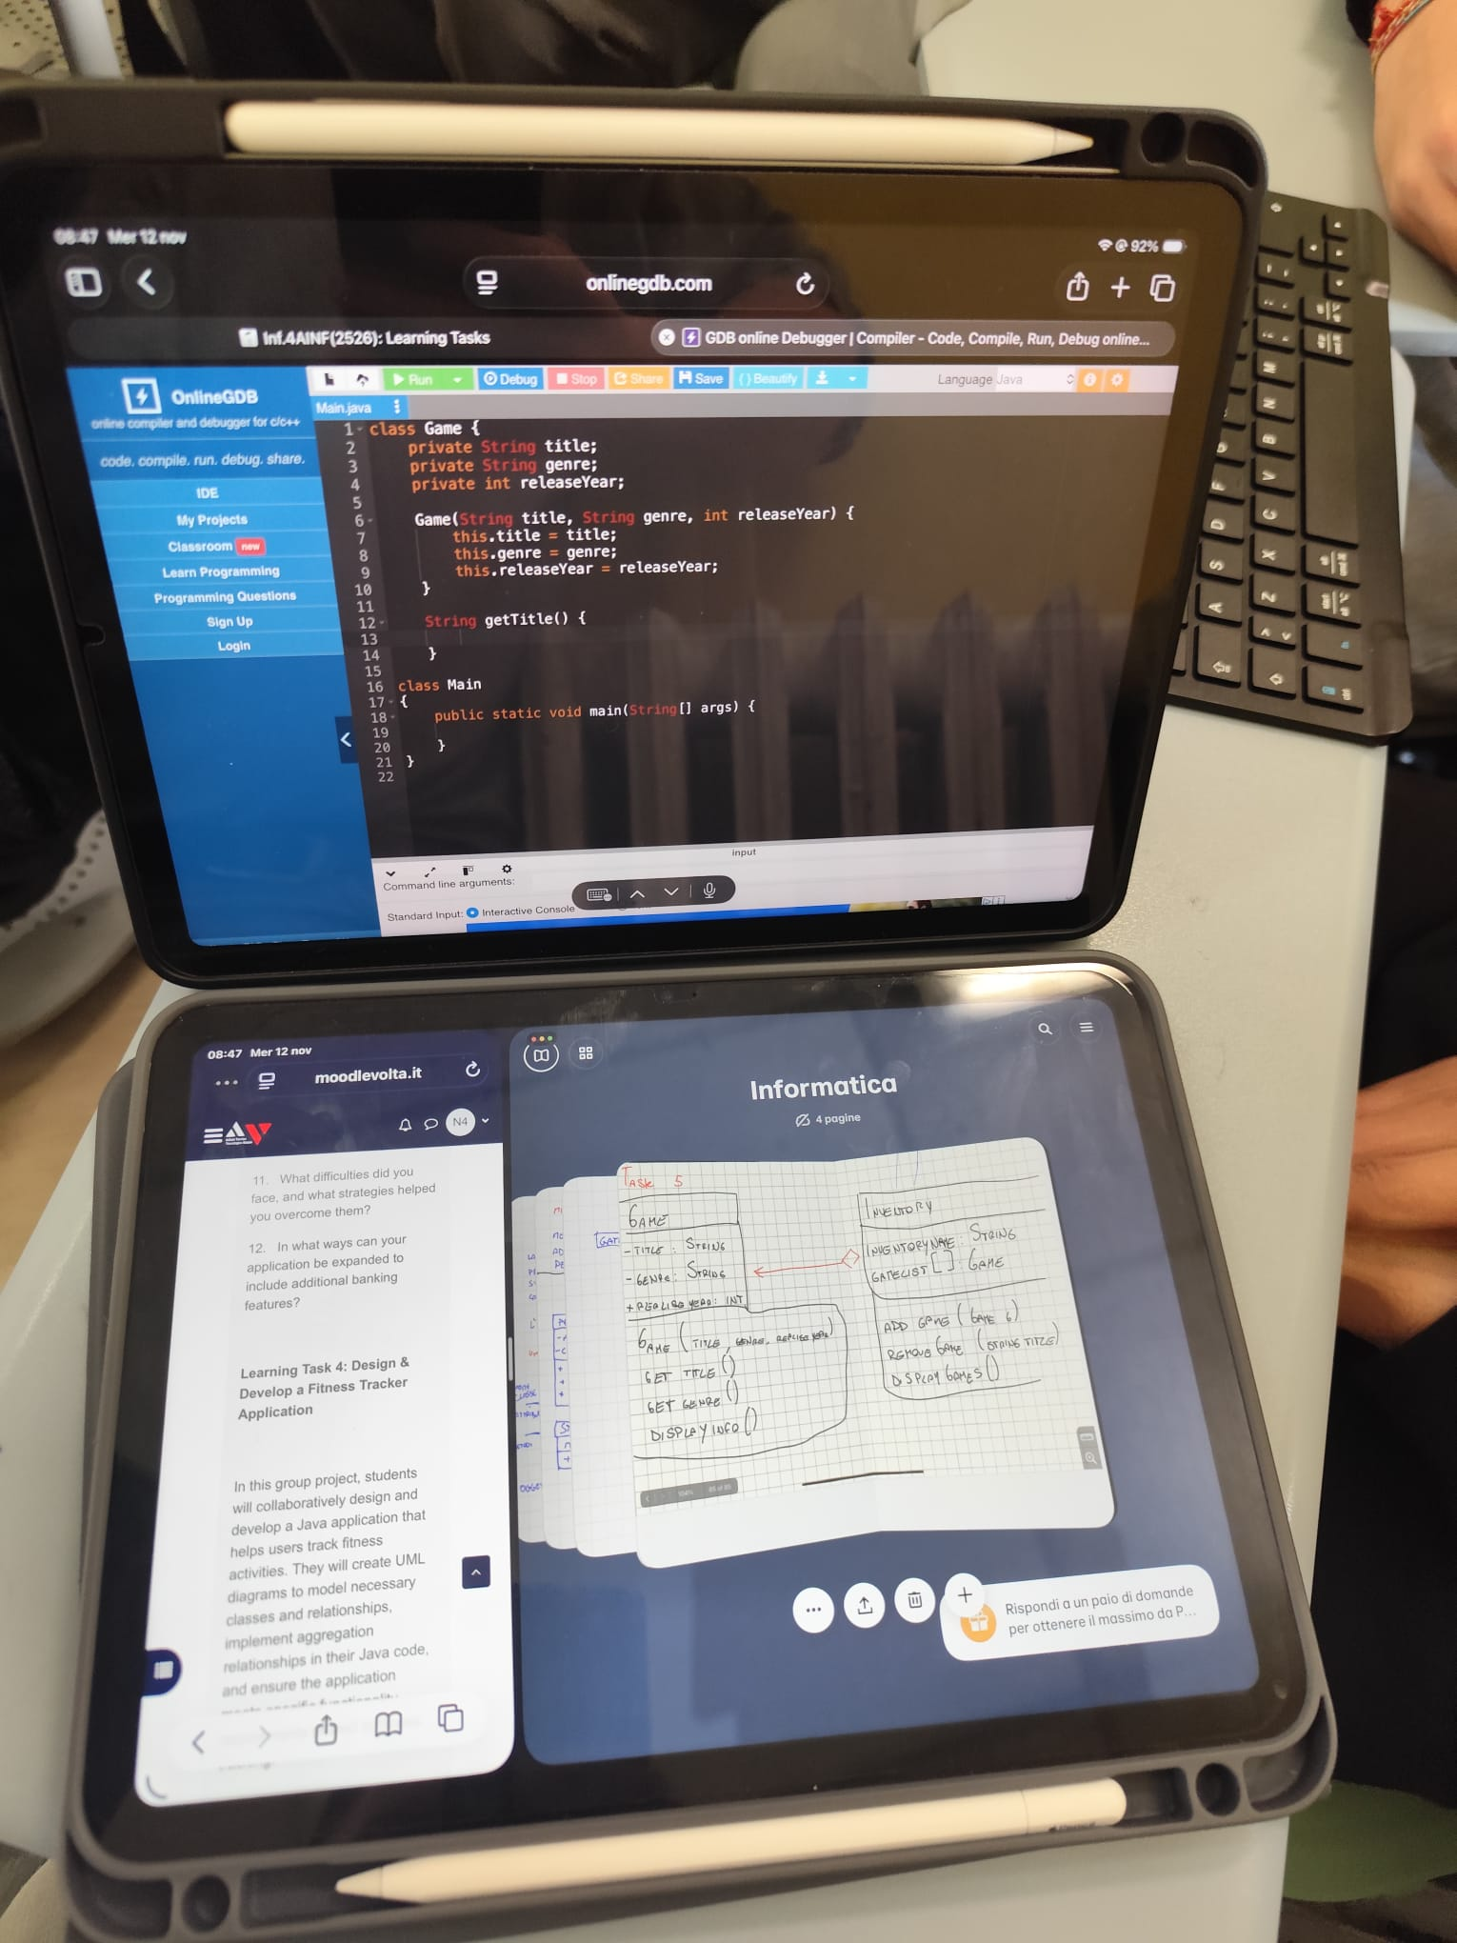
Students working on a Java project during Phase 3, with code and handwritten UML notes side by side.
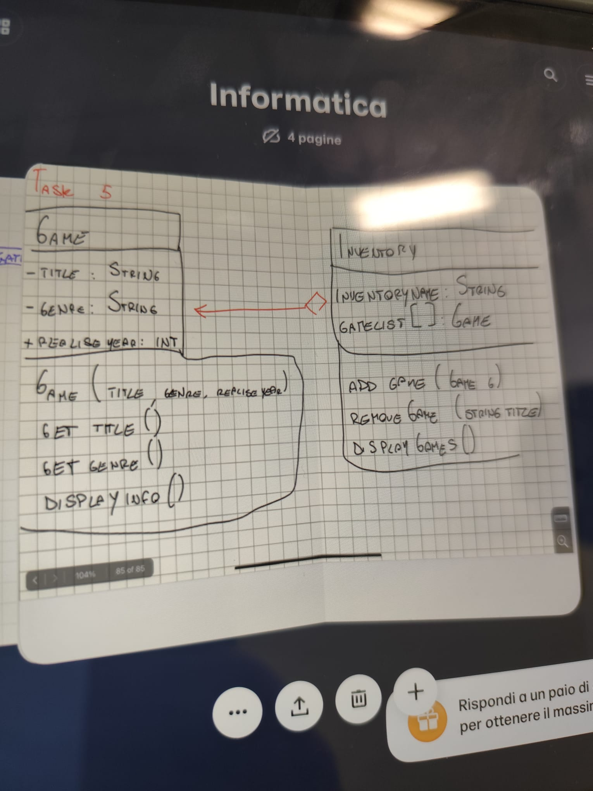
A student's handwritten UML diagram for the Java game project (Task 5), worked out from the platform brief.
Students described different levels of comfort using English during the work:
"We use English sometimes in class, so doing this in English was okay for me."
Student, Group 1
"It's useful for us. Speaking and coding in English helps us improve."
Student, Group 2
"English is important for our future, so I like practising it this way."
Student, Group 4
One student found the English 'a little too difficult'. The observers reported that students stayed involved and completed the tasks while the teacher circulated to support them.
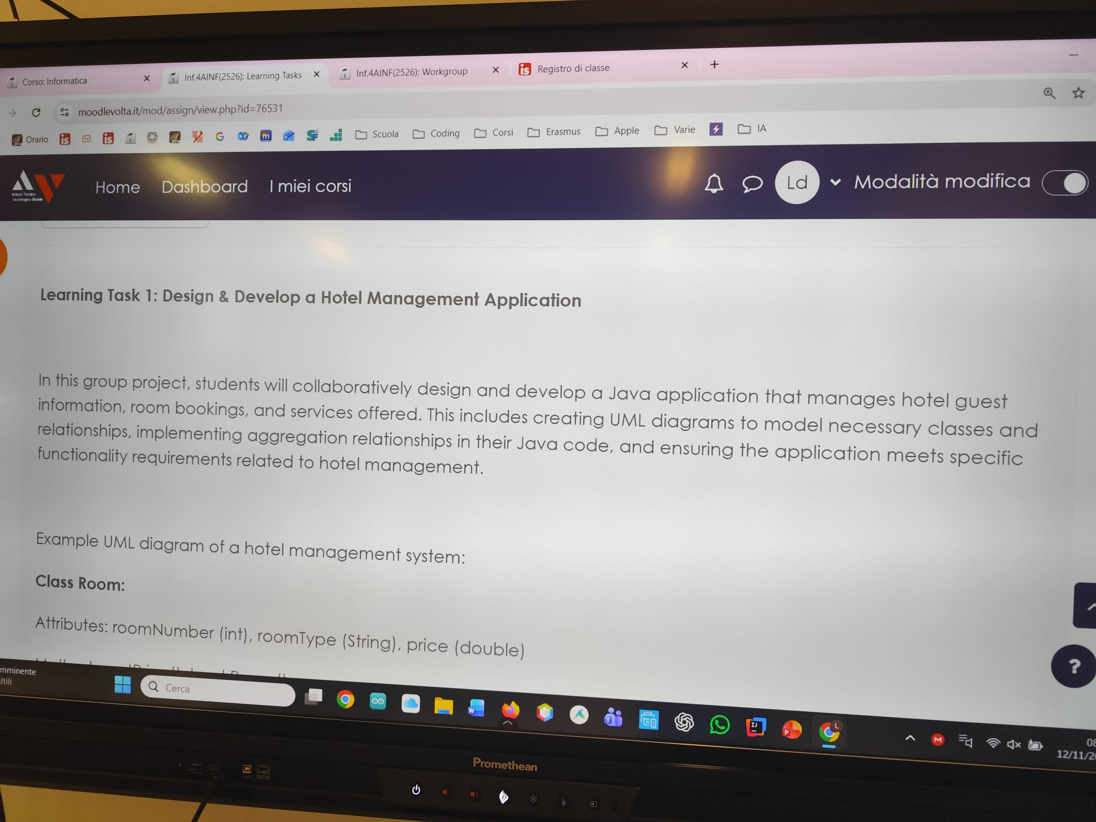
Learning Task 1 - Hotel Management. One of five project briefs the platform generated for the class.

Class 2: Poison Ball and Interactive Text (Frida Valecchi)
Frida used a generated text about TCP (Transmission Control Protocol) for a speaking activity called Poison Ball. A student read part of the text aloud; the student to their right asked the student to their left a question about it. Music played as the ball moved around the room, and the sequence continued.
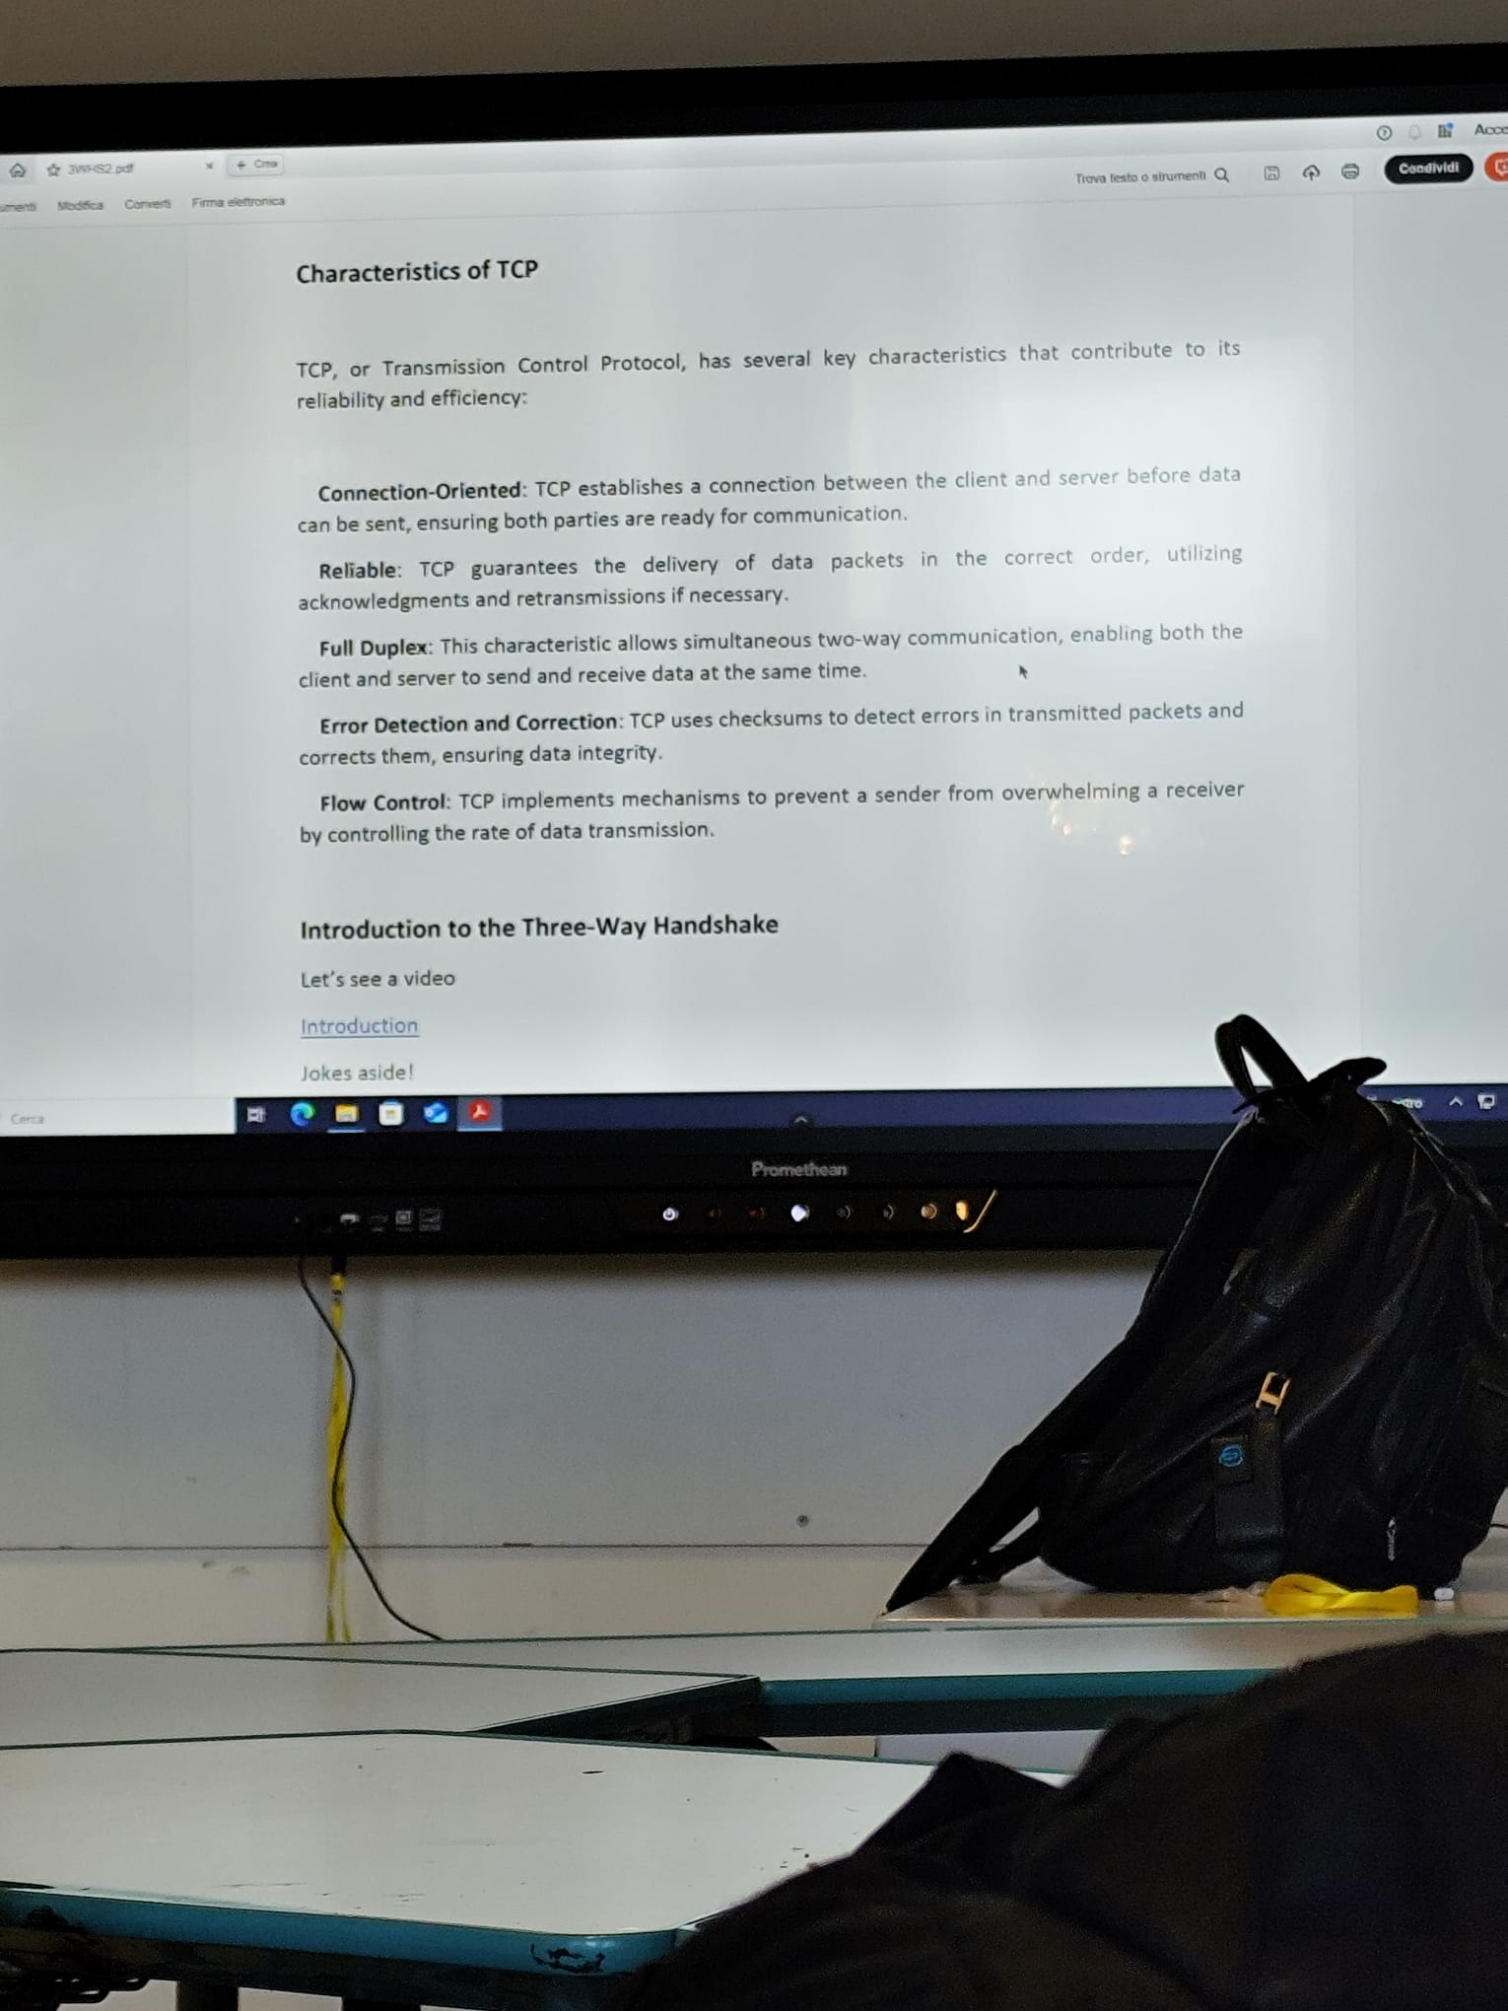
The platform's text on TCP, projected during Frida Valecchi's Poison Ball activity.
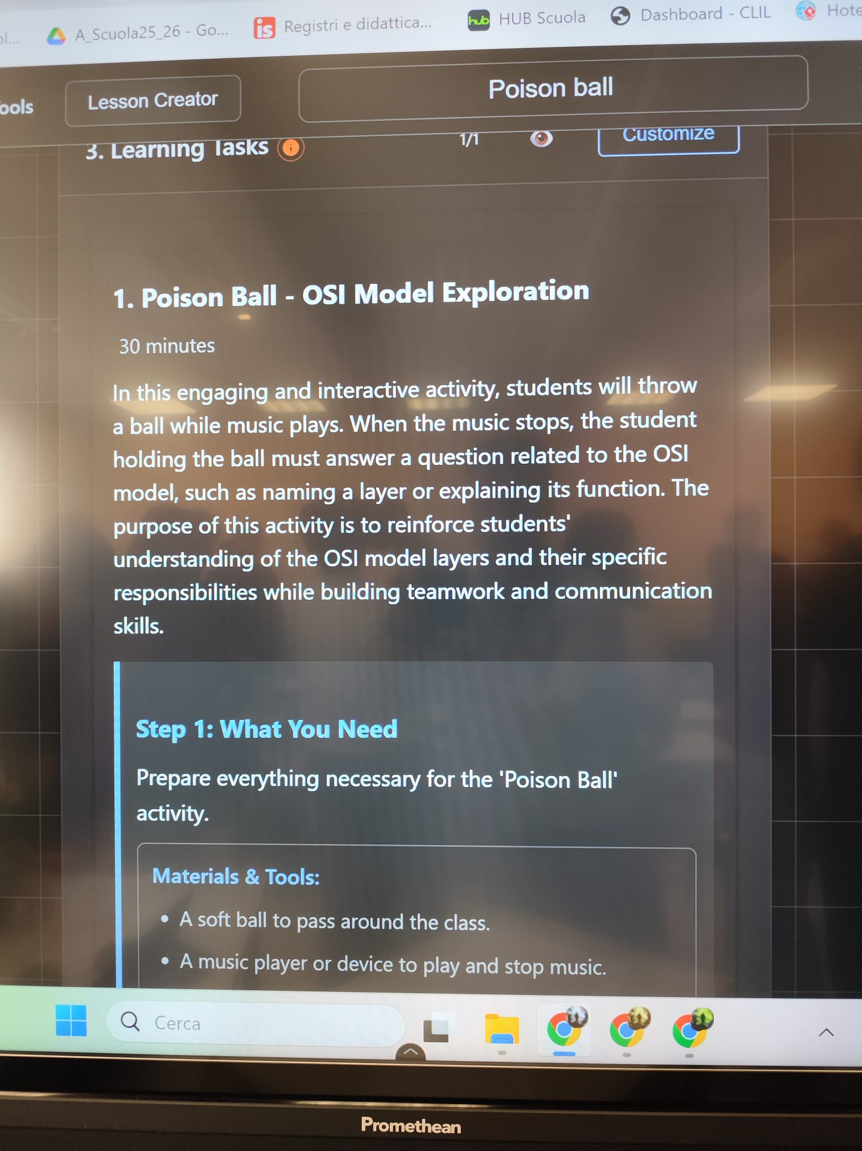
Poison Ball: OSI Model Exploration - the activity as generated in the Lesson Creator.
Frida reported several issues during the observed lesson:
• A discrepancy between what the teacher had asked the platform to produce and what it actually generated.
• The platform did not fully recognise that TCP belongs to the transport layer, which caused a small context mix-up.
• JSON output for one activity was not rendered as HTML, so it appeared as raw code on screen rather than as a formatted student task.
These observations were recorded for the development team to review.

Class 3: Direct Instruction and Presentation Mode (Francesco)
The teacher projected the output and guided the class through definitions and key points. Students interacted less than in the other two observed classes.
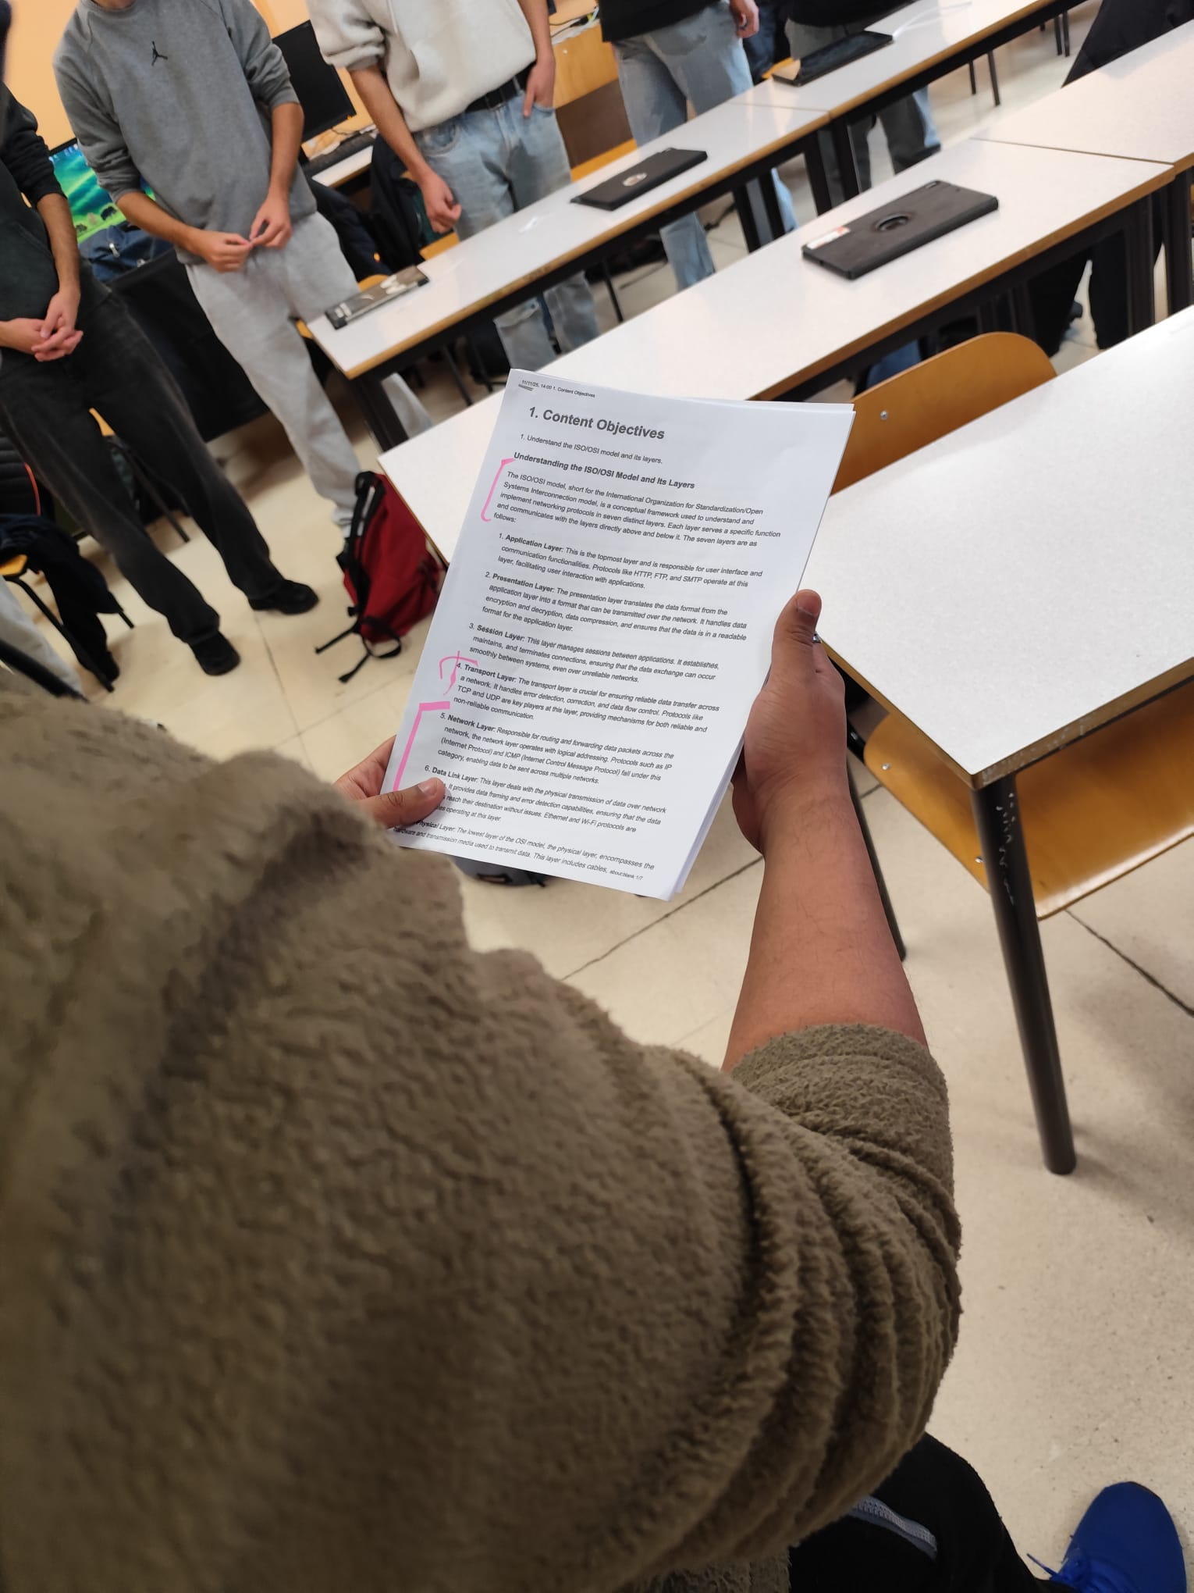
The platform produced a multiple-choice activity when the teacher had wanted presentation material. The visit report proposed better support for presentation-led teaching.

Classroom Approaches and Teacher Feedback
The observations showed three uses of the same platform: independent group projects, a teacher-designed speaking activity and guided explanation.
The visit combined live teacher feedback with classroom observation. Requests included saving a copy instead of overwriting a lesson, folders, text-to-speech, multi-language support, and better handling of technical subject context.
"We try to speak English, even if it's difficult."
Student feedback during Phase 3 observation
Ideas for your classroom
Select and reshape the output for your teaching approach. When trying a new resource, invite a colleague to observe what learners understand and where they need help.

Case Study 8: AI Applications and Benefits in Daily Life (4 CINF)
CLASS | 4 CINF; computer science; B2 English
SUBJECT | AI applications and benefits in daily life
TEACHER | Frida Valecchi, Alessandro Volta Institute
DURATION | Three linked sessions, January-March 2026
In three sessions across January and March, Frida asked students to explore where they encountered AI in daily life and what it did for them.
Students were asked to brainstorm individually. The assignment called for AI to summarise the pooled ideas and identify topics for further investigation.
The assignment asked students to work in groups, explore one aspect of the summary, and prepare a short written report. The planned final product was a podcast of up to ten minutes in which group members would discuss their concepts and opinions.
The assignment combined investigation of AI applications with discussion and collaboration in English.
A parallel activity, 'Discover and Podcast!', was underway in classes 5 CINF and 5 DINF in March. Groups were asked to research Starlink, in-vehicle LAN, Galileo (the European satellite navigation system), PAN, Neuralink or quantum internet, then prepare a report and dialogue-style podcast. The generated plan allocated three 50-minute sessions; the teacher's report marked the work as unfinished.
The spring 2026 report also checked lesson saving, editing, sharing, class settings, text-to-speech and interface languages. Frida reported dictation problems and a failed YouTube-source retrieval. These were observations of the trial version, recorded for technical follow-up.
Ideas for your classroom
Use an individual brainstorm to collect examples students can investigate. Agree what each group will research and how it will explain its findings.

Case Study 9: Implementation Lessons: Onboarding and Reliability
CLASS | 4 DINF; computer science; B2 English
SUBJECTS | JSON and Java; AI types and ethics
TEACHER | Francesco Casinini, Alessandro Volta Institute
FOCUS | Onboarding, generated resources, and link reliability
Dates: 29 April 2025 (JSON and Java); 20 May 2025 and 5 June 2025 (AI Types)
This case brings together two teaching strands in the Phase 2 trial: JSON and Java, and AI types and ethics. It also records the support needed by a teacher joining the trial later.

JSON and Java (April 2025)
JSON is a text format for structured data. In this trial, the teacher generated a B2-level CLIL activity about using JSON in Java, set the class parameters with students and checked access on iPads. The generated plan covered parsing, serialisation and key-value structures, with subject and language objectives, tasks and assessment.
Key vocabulary surfaced by the platform included JSON, parsing, serialisation, data structure, API, object, array, and key-value pair. Sentence frames such as "How does JSON function as a data format?" and "In what contexts might we use serialisation in Java?" gave students ready language for the discussion phase. The teacher refined the generated activity by adding specific needs - free Java libraries for reading and writing JSON files - and structured the work in two phases: first on JSON basics, then a small Java programming project in which students imported a JSON file and saved program settings back into an output JSON file.

AI Types and Ethics (May-June 2025): Checking AI-Generated Resources
In the second strand, Francesco Casinini joined the experimentation later in the year, having previously been engaged in his PhD programme. His report highlighted the need for a clear, task-focused introduction to the tool.
"I was included in the experimentation phase at a rather late point in the year, as I had previously been engaged in my PhD program. This 'late entry' certainly caused some initial difficulty on my part in understanding how to build the activities. This could perhaps serve as a starting point for suggesting some ideas to make the explanation of how to use the tool simpler."
Francesco Casinini, Phase 2 report
Casinini was given a 20-minute tutorial video covering the whole tool. He found the video comprehensive but hard to follow because it covered many topics at once, including advanced ones, and recommended that it be split into shorter, scenario-specific clips: introduction and basic elements; activity generation; general editing of activities; editing a specific activity.
Casinini also reported problems with links in the suggested multimedia resources. His example of an AI Types activity included suggestions for Khan Academy, a TED talk, a Harvard Business Review article, a YouTube video, and Canva. Several links led to inactive pages, underlining the need to open and check suggested resources before using them in class.
Casinini also wrote that the tool "can offer valuable support to teachers and enhance the quality of activities for students" and said he wanted to test it further in the following school year.

School-Level Implementation Checklist
- Provide a short, task-specific induction rather than one long tutorial.
- Give teachers one manageable first task.
- Identify a colleague who can answer practical questions.
- Check generated links and resources before class.
- Save successful prompts and examples, and allow time for trial, feedback, and adjustment.

Part Seven: Teacher Toolkit

Prompt Bank
A useful planning prompt normally includes the role, learners, subject content, approximate language level, output, constraints, and a checking instruction. The examples below are starting points rather than scripts that must be copied exactly.
Prompt formula: role + learners + content + language level + output + constraints + checking instruction.
Example: You are supporting a vocational computer science teacher. Create a 45-minute CLIL activity on network security for 16-year-old students working at approximately B1 English. Include one content objective, two language objectives, six key terms, a pair task, sentence frames, and a five-minute exit check. Keep technical meaning accurate and identify anything the teacher should verify.
Reuse a useful prompt
Save prompts that produced useful material. Adapt them for the next class and check each new output.

For Adapting Texts
"Adapt the following text to B1 level for upper-secondary learners studying computer science through English. Keep the key technical meaning, shorten long sentences, and replace less common words where possible. List any technical terms that should still be pre-taught."
"Create three versions of this text at B1, B2, and C1. Keep the core ideas stable across all three. Then explain in a short note what changed in vocabulary, sentence structure, and density."
"Rewrite this text for classroom comparison. Produce the original and a more accessible version, plus five discussion questions asking students to compare wording, meaning, and difficulty."

For Vocabulary and Language Support
"Extract the ten most important terms from this text for B1 learners. For each, give a student-friendly definition and one example sentence connected to the topic."
"Create a vocabulary support box for a CLIL lesson on [topic]. Include key words, simple definitions, likely confusing terms, and two sentence starters for pair discussion."
"Identify subject vocabulary and language for participation. Suggest language that may arise during discussion, and leave space to record language that actually emerges."

For Activities and Tasks
"Generate a 45-minute CLIL activity on [topic]. Include a short warm-up, a main collaborative task, language support, and a short reflection."
"Create a group task for students learning [topic]. Include content goals, language goals, materials, step-by-step instructions, possible difficulties, and wrap-up questions."
"Turn this technical reading into a three-stage lesson: pre-reading, while-reading, and post-reading. Each stage should support both content understanding and language use."

For Lesson Planning
"Turn this existing lesson into a CLIL lesson plan. Add one content objective, two language objectives, key vocabulary, lesson stages, scaffolds, and one short assessment check."
"Create a 60-minute lesson on [topic] for mixed-ability learners. Keep the subject challenge high but add language support where needed. Include teacher notes for likely problem points."

For Differentiation
"Create versions of this task for the learner profiles below. Keep the content goal, vary the language support, and explain each change."
"Generate a simplified follow-up for learners who found the first task too difficult. Keep the same topic, reduce the linguistic load, and make the instructions more direct."

For Assessment
"Create a short formative assessment for this CLIL lesson. Include three content-check questions, two language-check prompts, and one reflective exit ticket."
"Generate an assessment rubric for a group coding task. Include understanding of content, clarity of explanation, collaboration, and use of technical language."

For Pronunciation and Listening
"Generate a list of the ten words in this lesson most likely to be mispronounced by Italian-speaking students. For each, give the IPA transcription and a common mispronunciation to avoid." Verify specialist terms using a reliable dictionary or subject source because AI-generated IPA may be inaccurate.
"Create a short listening comprehension activity based on this text. Include five true-or-false statements and three open questions that check understanding of both content and vocabulary."

For Reflection and Metacognition
"Generate five reflective prompts for students to complete after this lesson. Each prompt should encourage them to think about what they learned, what was difficult, and how the English language affected their learning."
"Create a brief self-assessment checklist for students. Include three content knowledge checks and three language use checks that students can complete independently."

For Checking AI-Generated Material
Use these prompts to identify possible problems, then verify the answers against the source and your subject knowledge.
"Identify any technical claims in this material that require verification."
"Check whether important meaning or qualifications were lost during simplification."
"Identify cultural references that may be unfamiliar to multilingual learners."
"Find any instruction that may be unclear to a B1 learner."
"Check whether the proposed timing is realistic for a class of 24 students."

Worked Example: Checking a Hotel Delivery
This illustrative example is for hospitality learners who need support reading workplace instructions and reporting quantities in English.
Objectives
Subject: compare an order with the goods received and identify missing items.
Language: report quantities using ordered, received and missing, and explain a difference in a short sentence.
Original text
On receipt of a delivery, compare the quantities on the delivery note with the original order and the items received. Record any shortages or surplus items before confirming the delivery. A clear discrepancy note identifies the item, the quantity ordered, the quantity received and the difference.
Adapted text
When a delivery arrives, check three things: the order, the delivery note and the items. Count each item. Is anything missing? Is there more than you ordered? Write the item name and both numbers. Write the difference. Report the difference before you confirm the delivery.
Teacher choices
Keep the three-way check and the term delivery note. Explain delivery note as the list sent with the goods. Replace shortages and surplus with missing and more than ordered. Give the instructions one step at a time; keep the original text available for comparison.
Language support
Key words: order, delivery note, quantity, received, missing, difference.
Sentence frames: “We ordered ___ but received ___.” “There are ___ missing.” “The quantities match.”
Pair task
The delivery note lists the full quantities ordered. Check it against the goods below. One learner reads the order; the other reports the received quantities. Complete a discrepancy note, then swap roles to check it.
Item | Ordered | Delivery note | Received
Towels | 12 | 12 | 10
Pillowcases | 6 | 6 | 6
Duvet covers | 4 | 4 | 3
Matching assessment
Content: the note identifies two missing towels and one missing duvet cover; the pillowcases match. Ask the learner to explain how the difference was calculated.
Language: the learner states the quantities and the difference clearly, using the key words and sentence frames as needed. Record language errors separately from a correct calculation.
Reflection
After the task, note whether learners needed help with counting, reading the documents or explaining the difference. Use that distinction to choose the next activity.

Planning Templates, Checklists, and Rubrics
Topic
Class / learner profile
Content objective
Language of learning
Language for learning
Possible language through learning
Key vocabulary
Input support
Main task and final product
Scaffolds
Assessment
Teacher checks
Additional support
Extension

Text Adaptation Checklist
☐ Does the adapted text preserve the central meaning?
☐ Are essential technical terms and qualifications retained?
☐ Are difficult general words changed or explained?
☐ Are cultural references accessible or explained?
☐ Are sentence lengths and text organisation manageable?
☐ Has any important nuance disappeared?
☐ Has the teacher checked technical accuracy?
☐ Is the adapted text appropriate for this class, not only for a generic CEFR label?

Notes and changes to make:

Post-Lesson Reflection Template
What supported understanding most effectively?
Where did students still struggle?
Which scaffold did students use, and which did they ignore?
Did students use the target language to communicate about the content?
Was the subject challenge maintained?
What did I need to change?
What would I keep, change, or remove next time?
What is worth saving as a reusable prompt or template?

Sample Dual-Focus Assessment Rubric
Choose the criteria relevant to the lesson and adapt them to its objectives. Assess subject understanding separately from language accuracy. Use collaboration only when the task requires it. Assess performance with the agreed language support in place; using a glossary or sentence frame does not by itself lower the level.
Lesson or topic: ______________________________ Class: __________________
Date: ________________
Area | Secure | Developing | Needs support
Content understanding | Explains the key idea accurately and gives a relevant example. | Explains part of the idea correctly but leaves a gap or minor error. | Needs prompts or a model to explain the key idea accurately.
Application | Uses the concept correctly in the task and explains the choice. | Completes part of the task correctly but needs help applying the concept. | Needs step-by-step support to use the concept in the task.
Communication | Communicates a clear, organised explanation; language errors do not obscure meaning. | Main meaning is clear, but some points need clarification. | Needs further questions or modelling to make the main meaning clear.
Technical language | Uses the essential terms accurately in context. | Uses some key terms correctly; others need correction or support. | Needs further modelling to select and use essential terms accurately.
Collaboration | Contributes relevant ideas and responds to others to complete the task. | Contributes with prompting or responds inconsistently to others. | Needs an assigned role and support to contribute and respond.
Record the level for each selected criterion and one next step. Do not penalise the same language error under several criteria.
Teacher notes or adaptations:

Part Eight: Putting It Into Practice

Assessment in CLIL with AI Support
Assess both the intended subject understanding and the language students need to show it.
Decide in advance whether language is being formally assessed or is mainly a means of showing subject understanding. Avoid penalising the same language difficulty in several categories. AI may draft criteria, but the teacher sets the final standard.
• Assess understanding of the subject, not just language accuracy.
• Include opportunities for students to explain, describe, or justify their ideas.
• Use short formative checks during lessons rather than relying only on final tests.
• Provide language support within assessment tasks where appropriate.
• Use rubrics that are clear, simple, and aligned with lesson objectives.
In one project lesson, the teacher increased the weight given to collaboration and participation in a generated rubric. Adapt the criteria to the purpose of your own lesson.
Check understanding
End with a question that checks the lesson's content goal and asks students to explain their answer.

A First Classroom Trial
Try one supported text and a short pair task.
1. Choose one text you already use.
2. Generate one more accessible version.
3. Compare the source and adapted versions yourself.
4. Select six essential words.
5. Add two sentence frames.
6. Use the material in one short pair task.
7. Note what students found easier, harder, or still unclear.

What Students Told Us
The initial student learning-experience survey received 131 submissions between March and November 2025. The follow-up received 59 submissions between 13 April and 29 May 2026, including 58 complete sets of eight ratings. Each item shown below had 128 valid initial ratings and 58 follow-up ratings. Means are on a five-point scale; differences are calculated from unrounded means.
Student-reported item | Initial | Follow-up | Difference
Words used in lessons are easy to understand | 3.62 | 4.17 | +0.56
Lessons are structured to support engagement and retention | 2.95 | 3.72 | +0.77
Open responses were mixed. Some students reported that lessons were more interesting or easier to understand, while others noticed little or no change. Students repeatedly valued simpler language, practical examples, interaction, group work, and clear teacher explanation.
The anonymous survey rounds were not matched student by student. They measured perceptions of clarity, confidence, engagement and understanding, rather than directly testing language proficiency or academic attainment.

Key Lessons from the Project
The project examples used a cycle of generating material, checking it, adapting it and teaching with it.
CLIL can improve access without lowering expectations when language barriers are identified and supported.
Language support can benefit advanced learners as well as students who need more support.
Teacher judgement remains central to accuracy, sequencing, timing, grouping, and assessment.
Small, focused changes can be more sustainable than complete lesson redesign.

Frequently Asked Questions

Do I need to be an AI expert?
No. A clear purpose, a reasonably specific prompt, and careful review are enough to begin.

Is the platform intended for teachers or students?
It is primarily a teacher planning platform. Teachers decide what students see and how it is used.

What information should I avoid uploading?
Do not upload student names, sensitive personal information, identifiable assessment records, or material you do not have permission to process.

How accurate is the CEFR assessment?
It is an approximate AI-generated planning aid, not a formal assessment. Read the text and judge it against the real learners.

What should I do if a generated link does not work?
Search for the resource manually, replace the link, and check all links before class.

Can the platform be used in non-language subjects?
Yes. The project focused on programming, databases, networks, and other technical content. Language was not the main subject, but it influenced students' access to the content.

What if students have several language levels?
Keep a shared content goal and vary text versions, sentence frames, planning support, or output demands.

Can I use the Chrome extension on a school device?
The extension is available from the Chrome Web Store. Installation on a school-managed device depends on the organisation's policy. Ask your administrator if it is blocked, or add URLs directly in Resources.

How do I check whether an adapted text is still accurate?
Compare it with the source, check essential technical terms and qualifications, and verify any claim you are not certain about.

What is the simplest way to begin?
Adapt one text you already use, add six essential terms and two sentence frames, and try one short pair task.

Glossary
Term | Meaning
AI | Artificial intelligence: computer systems that generate, classify, predict, or transform information.
CEFR | Common European Framework of Reference for Languages, from A1 to C2.
CLIL | Content and Language Integrated Learning.
Content objective | What students should understand or be able to do in the subject.
Language objective | The language students need to understand, communicate, or complete the task.
Scaffold | Temporary support that helps a learner complete a task and can be reduced over time.
Prompt | An instruction or request entered into an AI system.
Text-to-speech | Synthetic audio generated from written text.
Hallucination | Plausible-looking but inaccurate or invented AI output.
Multilingual learner | A learner who uses or is learning more than one language.

Selected References
Council of Europe (2020). Common European Framework of Reference for Languages: Companion Volume.
Coyle, D., Hood, P., and Marsh, D. (2010). CLIL: Content and Language Integrated Learning. Cambridge University Press.
European Commission. Digital Education Action Plan 2021-2027.
European Commission (2026). Guidelines on the ethical use of artificial intelligence and data in teaching and learning for educators.
European Commission (2025). Making informed choices on digital education content: EU guidelines for teachers and educators.
Redecker, C. (2017). European Framework for the Digital Competence of Educators: DigCompEdu. Punie, Y. (ed.). European Commission Joint Research Centre.
European Commission. AI literacy: Questions and answers on Article 4 of the AI Act.
UNESCO (2023). Guidance for generative AI in education and research.

Publication Information
Official project title | Empowering Teachers with AI: A CLIL Integration Project
Project acronym | AI-CLIL-ET
Project reference | 2024-1-IE01-KA210-VET-000252978
Edition | English edition
Coordinating organisation | Teacher Academy Ireland Limited, Dublin, Ireland
Partner organisation | ISTITUTO TECNICO INDUSTRIALE STATALE ALESSANDRO VOLTA, Perugia, Italy
Platform | Open the AI-CLIL platform
Contact | patrickohare3@gmail.com
Recommended citation: Teacher Academy Ireland Limited and Istituto Tecnico Tecnologico Statale Alessandro Volta (2026). AI-CLIL Integration Handbook: A Practical Guide for Teachers. Erasmus+ project 2024-1-IE01-KA210-VET-000252978.
New original text and teaching materials created for this edition are licensed under CC BY-NC-SA 4.0. You may copy, share and adapt this content for noncommercial purposes, provided you credit the project partners, link to the licence, identify changes and distribute adaptations under the same licence. Logos, emblems, photographs, application screenshots, quoted sources and separately licensed material retain their respective rights and permissions.

Translating and Adapting This Handbook
To prepare a version for another language or teaching context:
1. Work from a copy of the editable handbook. Decide who will use it and which language students will learn; translating the teacher guidance need not change the lesson’s target language.
2. Ask a teacher familiar with the subject and CLIL to check terminology, instructions and language examples. Check any machine translation against the source.
3. Adapt curriculum references and illustrative examples to local needs. Keep historical case-study facts intact; label new local examples clearly.
4. Keep the interface labels readers will see in the application. Check screenshots, captions, links, tables and page layout, then ask a local teacher to try following one set of instructions.
5. Retain the original attribution and licence link, identify the translation or adaptation and its contributor, and state what changed. Check the separate permissions for photographs, logos and other excluded material.

Acknowledgements
This handbook was developed through close collaboration between the project partners and the teachers and students who tested the platform.

At Teacher Academy Ireland (Dublin)
Dr Robert Schwamborn, Director. Patrick O'Hare, project coordination and handbook development. Tomasz Laskowski, platform development. Gillian Cooke, CLIL methodology. Emma O'Hare, project support.

At the Alessandro Volta Institute (Perugia)
Fabiana Cruciani, Director. Laura Rosati and Lucia Vermigli, project coordination and classroom testing. Frida Valecchi, Francesco Casinini, and other Volta teachers, classroom testing and teacher feedback. Francesca Farinelli, project support and public presentation.
We also thank the students of classes 1 EQ, 3 AINF, 4 AINF, 4 CINF, 4 DINF, 5 AINF, 5 CINF and 5 DINF, whose feedback shaped both the platform and this handbook.
Funded by the European Union. Views and opinions expressed are, however, those of the author(s) only and do not necessarily reflect those of the European Union or Léargas. Neither the European Union nor Léargas can be held responsible for them.
Project Reference: 2024-1-IE01-KA210-VET-000252978

